**PRIVATE PARKING AGREEMENT No…….**

**BETWEEN**

**XXXX**

**AND**

**……………………………………………**

**………………………..**

**FOR**

**THE PURPOSES OF APPLYING THE TOWN/SHIRE/CITY PARKING LOCAL LAW XXXX as amended**

**AT**

**Lot: .…… Street/Road, or Car park:......**

**WESTERN AUSTRALIA**

**1.** **LOCAL LAW**

* 1. Pursuant to the Local Government Act 1995, the City / Shire / Town of XXXX resolved on the Date to adopt the City / Shire / Town Parking Local Law as amended (Local Law). The Local Law commenced operation in the district Number of (XX) days after it was published in the Government Gazette (No. XX) on Date.
  2. The Chief Executive Officer of the City / Shire / Town has resolved to approve a private parking agreement being entered into with …………………. Pty Ltd. This agreement satisfies the provisions of clause XX of the Local Law, as an agreement to apply the Local Law to the marked parking areas located at ………..Street/Road Lot number…………, XXXX, Western Australia XXXX (Premises).
  3. The commencement date of this agreement is the date referred to in clause 5.

**2.**      **PURPOSE OF AGREEMENT**

2.1     This agreement is intended to authorise the employees appointed by the City / Shire / Town as authorised officers or persons to enforce the provisions of the Local Law at the Premises and to determine the roles and responsibilities of each of the parties.

2.2      This agreement will establish that the Local Law applies to the Premises in accordance with clause XX of the Local Law.

2.3 The parties agree that, under this agreement, where any infringement notices are issued by the City / Shire / Town in relation to the Premises, the Town will collect and retain all monies paid in relation to those infringement notices.

**3.** City / Shire / Town **RESPONSIBILITIES**

* 1. To patrol, investigate and action alleged contraventions of the Local Law, including disabled and time limited parking on the land detailed in the car park plan (if applicable)
  2. To instigate legal proceedings for any alleged contraventions of the Local Law, as required.

3.3 Supply advice and technical expertise in the administration of

parking matters for the Premises.

4.**……..………………… PTY LTD RESPONSIBILITIES**

4.1 To generally mark and maintain at its cost the individual vehicle parking bays within the Premises to an acceptable standard in accordance with AS1742.11.

4.2 Install and maintain at its cost the signs detailed in Schedule1, as follows –

1. Adjacent to each entrance into the …….. car park install, sign number 4;
2. In each disabled parking bay, install sign number 1 and 3; and
3. Install sign number 2, as necessary.
   1. To ensure that all reasonable assistance is provided to the City / Shire / Town in enforcing the Local Law at the Premises, including but not limited to ensuring that an employee or representative of the company is available to supply relevant documents and attend Court in the event the City / Shire / Town commences court proceedings.
   2. To maintain at its cost all infrastructure in the designated carpark to a safe and trafficable level and not fall into a state of disrepair. Minimum maintenance includes:
      1. Carpark free from loose paving debris, building materials, and rubbish,
      2. Has functioning drainage systems, routinely cleaned and inspected,
      3. Has safe trafficable pavement (asphalt, concrete or other) with no large potentially dangerous potholes,
      4. If the company wishes to have an infringement withdrawn at a later date, the company understands that this will only take place if the company pays a service fee of $XX to the Town.

**5.    DURATION AND AMENDMENT**

This agreement will take effect from the date the agreement is signed by both parties and will remain in force unless terminated.

**6.    TERMINATION AND VARIATION**

(a) This agreement may be terminated by either party by giving the other party not less than 30 days’ notice in writing.

(b) Subject to subclause (a) above, this agreement and the nature and duration of the parking restrictions applying may only be varied by the written agreement of both parties.

(c) Upon the Local Law being repealed, this agreement will terminate and the parties will need to enter into a new agreement for the Premises.

(d) This agreement is between the undersigned property owner or nominated representative and the City / Shire / Town. Should the owners change or the City / Shire / Town cease in its current state, the agreement is then terminated.

**7.    NOTICES**

Notices or other communications to each of the parties must be in writing and addressed and forwarded as follows:

Mr/ Mrs…………

Pty Ltd…………….

Address…………..WA……

&

Chief Executive Officer

City / Shire / Town  
Address

**8.    PRIVATE PARKING AGREEMENT No…………..**

BETWEEN

XXXX

Address

AND

………….. Pty Ltd

……………………..

….……..WA ……..

SIGNED for and on behalf of ……………. Pty Ltd, by: …………………

______________________          ______xxxxxxe vehicle lease des y breakdown and includes OTsome comments or amend as necessary. and alternate method of constru______________ ______________

DIRECTOR/OWNER Signature                           Date

SIGNED for and on behalf of the City / Shire / Town by:

Name        ____________________________     _____________

CHIEF EXECUTIVE OFFICER                 Signature                              Date

**SCHEDULE 1 guide**

**PARKING SIGNS per AS 1742.11**

**(Sign 1)**  **(Sign 2)** x=1P; 2P or 3P

X Hours Parking Signs

DISABLED PARKING (Elevated Sign)

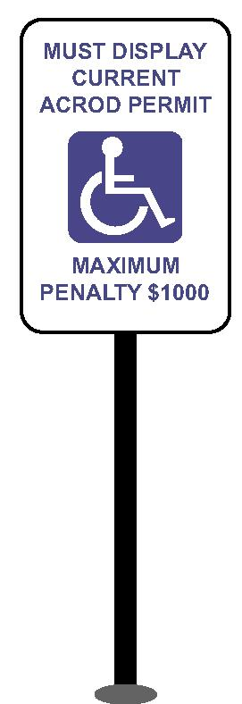

General

**x3**



**$5000**

x Hour Parking Only

**(Sign 4)**

Access Point Signs

**(Sign 3)** 900 x 900mm

Ground Markings

Standard Width Bay

2.5 metres



**CAR PARK xx TOWN/SHIRE/CITY**

**Private Parking Agreement No: ………**

**Parking and Parking Facilities Local Law XXXX**

XX Hour Parking Only

Mon-Sat

8.00am-6.00pm



MAXIMUM PENATLY $5000.00

**xP PPPPPP3 P**