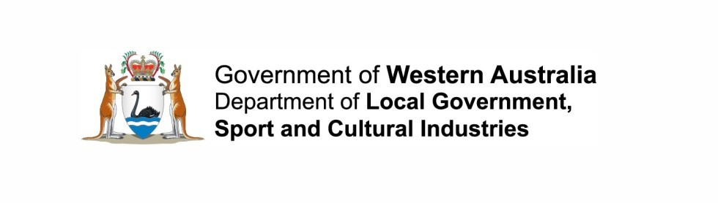
Regional Subsidiaries - Public Consultation Guidelines

July 2017
E1712153
Contents
Introduction 3
Objective 3
Legislation 3
Local Government Act 1995 3
3.69. Regional subsidiaries 3
Local Government (Regional Subsidiaries) Regulations 2016 3
9. Community consultation about formation of regional subsidiary 3
Public consultation 4
Preparation of business plan 4
Advertising business plan for comment 4
Consideration of submissions 5
Significant change to proposal 5
Amendment to charter 6
Application to the Minister 6
For more information please contact: 7

Regional subsidiaries – Public Consultation Guidelines (July 2017)
Prepared by: Department of Local Government, Sport and Cultural Industries
140 William Street, Perth WA 6000, GPO Box R1250, PERTH WA 6844
Tel: (08) 6551 8700 Fax: (08) 6558 1555 Freecall: 1800 620 511 (Country Only)
Email: legislation@dlgsc.wa.gov.au Web: www.dlgsc.wa.gov.au
Translating and Interpreting Service (TIS) - Telephone: 13 14 50
All or part of this document may be copied. Due recognition of source would be appreciated. If you would like more information please contact the Department of Local Government, Sport and Cultural Industries.

Introduction
Two or more local governments have the ability to form a corporate entity for the purposes of carrying out joint services or activities in their collective districts. This entity is known as a “regional subsidiary”.
As part of the process of forming a subsidiary, the local governments must carry out consultation and endorse a draft charter which will govern the subsidiary.

Objective
This document provides guidance on what consultation must be conducted prior to requesting the Minister’s approval to form a subsidiary or amend the charter of a subsidiary.

Legislation

Local Government Act 1995

3.69. Regional subsidiaries
(1) Two or more local governments making arrangements under which they are to provide a service or carry on an activity jointly may, with the Minister’s approval and in accordance with the regulations, form a subsidiary body (called a regional subsidiary) to provide that service or carry on that activity.

Local Government (Regional Subsidiaries) Regulations 2017

9. Community consultation about formation of regional subsidiary
(2) Before applying to the Minister for approval for the formation of a regional subsidiary, the participants are required to consult with the community in their districts in accordance with this regulation.

Public consultation
Before making an application to the Minister, the local governments must carry out the public consultation process specified in the Regulations.
This process involves the following steps:
- A business plan must be prepared for the regional subsidiary
- The business plan must be advertised for comment
- All submissions must be considered.

Preparation of business plan
The Regulations require a business plan to be prepared that sets out the impact the subsidiary will have on the district. This plan will assist stakeholders to make submissions on whether the subsidiary should be formed.
The plan should contain sufficient detail so that stakeholders can determine what the subsidiary will do and what financial risks or obligations are likely to be involved.
The business plan can be prepared collaboratively by member local governments, however:
- The plan should contain detailed information on how each district will be affected by the proposed subsidiary, and
- The same business plan should be advertised in each affected district.
Further information to assist in the drafting of a business plan can be found in the ‘Regional Subsidiary Business Plan Guidelines’ located on the Department’s website.

Advertising business plan for comment
Once the business plan is prepared, it will need to be advertised for public comment.
The Regulations require a public notice to be issued in each affected district. This notice must clearly state that:
- There is a proposal to form a regional subsidiary
- Submissions can be made to the local government before a deadline specified in the notice, and
- The business plan will be available for inspection on the local government’s website and at the local government’s office.
The deadline specified in the notice must be no less than 6 weeks after the date of the publication of the notice. To avoid procedural errors, a minimum of 7 weeks
is recommended.

Consideration of submissions
The consideration of submissions should be in line with the following principles:
- Submissions from non-ratepayers or from individuals located outside the district must still be considered

- Submissions from other local governments must be considered

- The submissions received by a local government may be provided to another local government, but there is no requirement to do so, and

- Submissions received after the submission period may be considered at the local government’s discretion.
Local governments will need to demonstrate that all submissions were duly considered.
At a minimum, submissions must be analysed and all relevant information should be presented to the council in a report.
The due consideration of submissions should be clearly stated in a council resolution, however, this does not necessarily need to be the same resolution in which the subsidiary’s charter is endorsed.

Significant change to proposal
As the local governments negotiate the formation of the subsidiary, it is possible that the proposal may change from what was initially advertised.
The Regulations require a business plan to be revised and readvertised if there is a “significant change” to the proposal after the plan is advertised.
The Regulations define a significant change to mean a change to either:
- The proposed membership of the subsidiary, or
- The proposed purpose of the subsidiary.
Local governments should keep this in mind if they prepare and advertise a business plan prior to drafting the subsidiary’s charter. This is because the charter may impact the information in the business plan.
For the purposes of the Regulation, the Minister will determine whether sufficient advertisement has occurred and whether a proposal was amended to such an extent that readvertising is necessary.
Any consultation beyond the requirements of the Regulations will not be subject to any further regulatory compliance and is left to the discretion of each local government.

Amendment to charter
Once a subsidiary is formed, any proposal to make a significant change to the subsidiary’s charter will require consultation.
The consultation process for amendments is similar to the process required to form a subsidiary but with the following changes:
- Local governments must advertise the amendment and reasons for the amendment, rather than a business plan, and

- If the amendment will result in another local government joining the subsidiary, that local government’s district must be included in the consultation.
Consultation is not required for non-significant changes to a subsidiary’s charter,
but local governments may still carry out consultation at their discretion.

Application to the Minister
Once a formal application has been submitted to the Minister, the application will be assessed to determine whether the local governments have carried out the requirements of the Act and Regulations.
The documents to be provided to the Minister and the applicable policies are addressed in “Approval Policy – Regional Subsidiaries” available on the Department’s website.

For more information, please contact:
Department of Local Government, Sport and Cultural Industries
Gordon Stephenson House, 140 William Street, Perth WA 6000
GPO Box R1250, Perth WA 6844, Telephone: (08) 6551 8700, Fax: (08) 6552 1555,
Freecall: 1800 620 511 (Country only)
Email: legislation@dlgsc.wa.gov.au
Website: www.dlgc.wa.gov.au/AdviceSupport/Pages/Regional-Subsidiaries.aspx
Translating and Interpreting Service (TIS) – Telephone: 13 14 50

