Western Australia

Combat Sports Act 1987

Mixed Martial Arts Contest Rules 2020
Western Australia

Mixed Martial Arts Contest Rules 2020
Contents
Part 1 – Ring/Enclosure Requirements
- Safety enclosure Type Contest Area Specifications 4
- Ring Type Contest Area Specifications 4
- All Contest Area Step Requirements 6
- Contest Area Construction and Maintenance 6
- Certified Structural Engineer Report 6
- Compulsory Ringside Requirements 6
- Other Permitted Ringside Requirements 7

Part 2 – Dress Code

- Hand Bandages and Tape 8
- Gloves 9
- Mouthguards 10
- Contest Attire – Contestants 10
- Contest Attire – Officials 11
- Other Dress Code Matters 11
- Foreign Substances 11

Part 3 - Conduct of the Contests
- Minimum Age to Participate in a Contest 12
- Weight Divisions 12
- Weigh-In 13
- Experience Limit Requirements 14
- Round Definition 14
- Permitted Strikes 15
- Permitted Grappling Techniques and submissions 16
- Scoring 17
- Elements to be Considered When Scoring 18
- Scorecards 18
Part 4 – Official Requirements and Duties
- Required Officials 20
- Duties and Responsibilities of the Promoter 20
- Duties and Responsibilities of the Referee 21
- The Powers of the Referee include: 23
- Duties and Responsibilities of the Judges 24
- Duties and Responsibilities of the Timekeepers 25
- Duties and Responsibilities of the Medical Practitioner 26
- Conduct of Commission Representatives, Officials 27
and the Medical Practitioner
- Duties and Responsibilities of the Trainer 27
- Duties and Responsibilities of the Seconds 28

Part 5 – Rules of the Contest
- Accidental Foul 28
- Accidental Injury 30
- Accidental Low Blow (No Foul Rule) 30
- Cut-Eye Rule 32
- Decisions 33
- Definition of a Grounded Opponent 33
- Disqualification 34
- Double Knockout 34
- Failure to Leave the Corner 34
- Fouls 35
- Fouls Committed by Bottom Contestant 37
- Inspection During Rest Period 37
- Intentional Foul 37
- Loss of Mouthguard 38
- No-Contest 38
- No-Decision 38
- Out of the Contest Area 39
- Restrictions Following a Contest 39
- Restrictions Following a Knockout 39
- Stalling 40
- Stopping a Contest 40

Part 6 - Miscellaneous
- Prohibited Substances 41
- Gender 41
- Sanctioning Bodies 41

Part 7 – Figures and Diagrams
- Standard Ring Layout 42
- Standard Hexagonal Enclosure Layout 43
- Standard Octagonal Enclosure Layout 44
- Standard Circular Enclosure Layout 45
- Sample Scorecard 46

Part 8 - Breaches 47
Part 9 – Summary 47

Combat Sports Act 1987

MMA Contest Rules 2019
Part 1 - Ring/Enclosure Requirements

- Safety Enclosure Type Contest Area Specifications

- In all contests, the contest area shall be circular or have at least five (5) equal sides and shall be no less than 6.0m wide and no more than 9.8m wide.
- The floor height should be a maximum of 1.2m above the floor of the building.
- The contest area may have one (1) or two (2) entrances.
- The enclosure posts must be made of metal, not more than 15cm in diameter, extending from the floor of the building to a minimum height of 1.5m above the floor ring, and must be properly padded in a manner approved by the Combat Sport Commission WA (the Commission).
- The floor must be padded by a layer of rubber, soft cloth, rubber mat or other suitable material that is approved by the Commission with a minimum thickness of 2.5cm and a maximum of 3.7cm.
- The padding shall be completely covered by a non-slip canvas or similar material tightly stretched and laced to the platform of the contest area. Material that tends to gather in lumps or ridges must not be used.
- The walls of the enclosure shall be made of a suitable chain link fence coated with vinyl or an appropriate substance (i.e. powder coat).
- There must not be any obstruction on any part of the walls surrounding the contest area.
- Any logos or images painted onto the canvas/cloth must consist of a non-slip material/paint.

- Ring Type Contest Area Specifications
- In all contests, the size of the ring shall be no less than 5m x 5m and no more than 9m x 9m inside the line of ropes. The ring lighting must be appropriate and adequate for the conduct of combat sport contests.
- All contest rings:
- The floor height should be a maximum of 1.2m from the building floor.
- There will be four (4) ropes with a minimum diameter of 3cm and a maximum of 5cm, stretched and linked to the four (4) corner posts.
- The top rope is to be a minimum of 1.25m and a maximum of 1.35m from the floor with the other three (3) ropes distributed at equal distances between the top rope and floor.
- The ropes will be covered by a soft or cushioned material and shall be joined on each of the four (4) sides at equal intervals by rope stays hung vertically, that are not less than 3cm and not more than 4cm wide, and that do not slide along the ropes.
- A minimum of five (5) rope stays must be used on each side of the ring.
- Turnbuckles shall be covered by suitable padding.
- The floor must be padded by a layer of rubber, soft cloth, rubber mat or other suitable material that is approved by the Commission with a minimum thickness of 2.5cm and a maximum of 3.7cm.
- The padding shall be completely covered by a non-slip canvas cloth that is stretched and secured into place.
- Any logos or images painted onto the canvas/cloth must consist of a non-slip material/paint.

- All Contest Area Step Requirements

- Three (3) sets of steps are required to the height of the ring platform;
- One (1) set is to be located at each Contestant’s corner and a third shall be positioned at the neutral corner closest to the Medical Practitioner and other officials.
- Two (2) sets of steps are required to the height of the enclosure platform.
- Must always be kept clear of obstruction.

- Contest Area Construction and Maintenance

- Newly constructed rings and enclosures must have a Certified Structural Engineer Report prior to being used.
- Rings must be checked for wear and tear every three (3) years and an updated Certified Structural Engineer Report submitted to the Commission.
- It is the Promoters responsibility to ensure that the Certified Structural Engineer report is current.

- A Certified Structural Engineer Report must include

- A certified structural engineer report must include-Level of metal fatigue.
- Damage sustained to supporting boards.
- All wear and tear.
- The load capacity – load capacities must be greater than 850kg or equal to twelve (12) people.
- A contest area must not be used by a Promoter for a contest or contests unless the area has been inspected by a Certified Structural Engineer to ensure compliance with the specifications above.

- Compulsory Ringside Requirements

- In all contests, the Promoter is responsible for ensuring that the following are placed at ringside:
- Oxygen supply unit.
- Stretcher.
- Spare set of gloves for each contestant.
- A bell in good working order.
- Two (2) stopwatches/ timers.
- Tables and chairs for officials.
- Judges score sheet.
- Whistle and clacker.
- A bin in the neutral or Medical Practitioner’s corner for gloves and refuse.
- Stools for each corner.

- Other Permitted Ringside Requirements

- Drinking bottles, buckets and spray bottles.
- Towels.
- One (1) set of round indicators, signs or boards.
- Blunt edged scissors.
- Extra tape for taping gloves.

Part 2 - Dress Code
- Hand Bandages and Tape

- Hand bandages are mandatory.
- The bandages and tape must conform to the following specifications and conditions.
- Hand bandages must be:
- Crepe, gauze or a soft cloth type material.
- Not be more than five (5) metres long and five (5) centimetres wide for each hand.
- Placed on both of the Contestant’s hands.
- There is to be no hard build-up of any material over the knuckles.
- Adhesive tape:
- May be used to secure the bandages on each hand of the Contestant.
- Must be no more than two and a half (2.5) metres long and two and a half (2.5) centimetres wide for each hand.
- May be applied to the back of each of the Contestant’s hands but shall not be applied to cover the Contestant’s knuckles. Tape cannot reach beyond or cover the knuckles when the fist is closed.
- May have tape applied directly to the skin or the Contestant may have cotton or gauze placed under the tape.
- Thin strips of adhesive tape may be placed between the fingers to aid in keeping the bandage in place.
- Bandaging and Taping of Contestant’s Hands:
- Shall be conducted in the dressing rooms. Contestants arriving at a contest venue with their hands already wrapped will be asked to remove the hand wraps and have them re-wrapped at the venue.
- Shall be in the presence of the Head Referee or a Commission Representative (if necessary).
- Shall be inspected and signed upon completion by the Head Referee or a Commission Representative (if necessary). Bandages or tape will not be affixed in any way that the Head Referee or a Commission Representative consider detrimental to an opponent.
- If the indentation in between knuckles can be felt and there isn’t any tape over the knuckles or excessive buildup the wraps may be approved.

- Gloves

- All Contestants shall wear gloves that are approved by the Commission.
- Gloves must be new or near new, with Velcro and without any misshapen or lumpy padding, worn or cracked leather or in any way imperfect. If gloves are in any way imperfect, they must be changed before the contest begins in the presence of a Referee or Commission Representative (if necessary)
- Gloves must be either red and blue or must be taped with red or blue tape wrapped around the wrist.
- Breaking, roughing, twisting is not permitted.
- If a glove becomes damaged during a contest it shall be replaced during the interval between rounds, unless, at the discretion of the Referee, the contest is stopped during the round to have the glove replaced, in which case the Timekeeper must stop the clock and restart it when the round is resumed.
- Gloves shall not be put on until the Head Referee or a Commission Representative (if necessary), has signed the bandages.
- A Contestant shall be fitted with gloves immediately prior to the contest under the supervision of the Head Referee or a Commission Representative (if necessary).
- The Velcro of the gloves must be securely covered by adhesive tape and signed by the Head Referee or a Commission Representative (if necessary).
- When taping the gloves, the tape must not go past the wrist.
- The Promoter must supply the gloves and must ensure that there are adequate sizes for all Contestants.

- Mouthguards

- In all contests, mouthguards must conform to the following standards and practices:
- A Contestant shall wear a professionally fitted mouthguard during a contest.
- The Contestant’s mouthguard shall be examined by the Referee prior to the contest and at the start of each round.

- Contest Attire – Contestants

- In all contests the following dress standards must be adhered to by Contestants:
- A Contestant must be clean and present a tidy appearance. This includes not wearing any attire that displays obscene language or profanity.
- Head protection may be worn if agreed by both contestants.
- A Contestant’s facial hair must not interfere with the safety of either Contestant.
- Contestant hair must be neat and tidy with long hair tied back to remove hazard and not to cause interference with the safety of the either Contestant.
- Gloves as specified.
- A groin protector must be worn and if using ties, tied only at the back. Metal groin guards are preferred.
- Male Contestants must fight naked to the waist.
- Female Contestants must also wear a top generally worn for combat sports contests.
- Breast protectors may be worn by female contestants which must be:
- Of a personal size, made of a soft material, and have no hard clips or such that could harm the wearer or opponent, and
- Firm enough not to shift during a contest.
- Each Contestant shall wear mixed martial arts shorts (board shorts), biking shorts (vale tudo shorts), kick-boxing shorts or other shorts approved by the Commission.
- Shoes and any type of padding on the feet are prohibited during competition.
- Contestants that present with skin conditions must be cleared by the Medical Practitioner that the condition is not contagious. Where additional clothing is required i.e. rash guard, skins or spats, both Contestants must agree to wear the same attire.
- Single elastic bandages (ankle straps) are allowed to be worn on the ankles to prevent sprains, however insertion of any sort of padding is prohibited.
- The use of white petroleum jelly or any similar substance by the Contestant anywhere other than the face is not allowed.
- No metallic materials, decoration or jewellery is to be worn.
- Any infringement to the dress code may result in Contestant disqualification.

- Contest Attire – Officials

- In all contests, the following dress standards must be adhered to by the contest officials:
- A Referee shall be neatly dressed in black dress pants, official shirt and black shoes without a heel.
- The Referee shall not wear glasses, watch, necklace, rings or any other object which may injure a Contestant.
- The Referee may wear a belt with a standard type belt buckle. Large or ornament type belt buckles will not be allowed.
- Referees must wear surgical gloves when officiating in the ring/enclosure.
- Judges and Timekeepers must be neatly dressed in black dress pants, official shirt and dress shoes and a blazer if applicable.

- Other Dress Code Matters

- In any contest:
- Application of Vaseline, liniment or similar on the body is not permitted.
- Excessive external use of water is not permitted.

- Foreign Substances

- When the Contestants have entered the ring/enclosure and prior to the start of the contest, the Referees shall inspect both Contestant’s gloves and body to ensure no foreign substances have been applied and must take steps to ensure that there are no foreign substances held by the Seconds.

Part 3 - Conduct of the Contests

- Minimum Age to Participate in a Contest

- Contestants are to be over the age of 18 for all Mixed Martial Arts contests that are run according to Combat Sports Commission rules or the rules of a recognised sanctioning body.

- Weight Divisions

- As prescribed by the Western Australian Combat Sports Regulations 2004 (the Regulations), Schedule 2, Division 3, the following weight classifications will apply:

Division (Class) | Weight Range (lbs.) | Min (kg) | Max (kg)
Straw weight | up to and including 115 lbs. | (no lower limit) | 52.16
Flyweight | over 115 to 125 lbs. | 52.16 | 56.70
Bantamweight | over 125 to 135 lbs. | 56.70 | 61.23
Featherweight | over 135 to 145 lbs. | 61.23 | 65.77
Lightweight | over 145 to 155 lbs. | 65.77 | 70.31
Super Lightweight | over 155 to 165 lbs. | 70.31 | 74.84
Welterweight | over 165 to 170 lbs. | 74.84 | 77.11
Super Welterweight | over 170 to 175 lbs | 77.11 | 79.38
Middleweight | over 175 to 185 lbs. | 79.38 | 83.91
Super Middleweight | over 185 to 195 lbs. | 83.91 | 88.45
Light Heavyweight | over 195 to 205 lbs. | 88.45 | 92.99
Cruiserweight | over 205 to 225 lbs. | 92.99 | 102.06
Heavyweight | over 225 to 265 lbs. | 102.06 | 120.20
Super Heavyweight | over 265 lbs. | 120.20 | (no upper limit)

- Weigh-in

- Contestants are required to submit to an initial weigh-in and a secondary weigh-in.
- Initial Weigh-in:
- Contestants are required to submit to an initial weigh-in.
- The initial weigh-in should take place no earlier than 24 hours prior to the advertised start time of contest (promotion), and no later than three hours prior to the of the advertised start time of contest (promotion).
- Contestants shall be weighed with minimum clothes.
- Minimum clothes are defined as: Male contestants being in light underwear or the like and female contestants being in light underwear and a bra top or the like. For the avoidance of doubt, no shoes or socks may be worn.
- Where a contestant is unable to weigh-in with ‘minimum clothes’ for cultural reasons, the contestant will be weighed in a private room in the presence of a Commission representative of the same gender.
- Contestants will have one attempt to weigh-in and make weight.
- Contestants must weigh within the nominated weight class. There will be a 500g allowance.
- Contestants that weigh outside of the weight class range will be subject to the Weight Policy of the Combat Sports Commission.
- Prior to the contest, all contestants must be examined and certified fit by an approved Nationally Registered Medical Practitioner.
- Contestants must present their Western Australian Combat Sports Commission Contestant Record Book to the Commission representative for authentication.
- The Commission representative will then provide the Medical Practitioner with the Contestant Record Book for completion at the end of the contest.
- Secondary Weigh-in:
- Contestants are required to submit to a secondary weigh-in.
- The secondary weigh-in will take place no earlier than the advertised start time (doors open) of contest (promotion) and no later than two hours after the advertised start time (doors open) of contest (promotion).
- Contestants shall be weighed with minimum clothes.
- Minimum clothes are defined as: Male contestants being in light underwear or the like and female contestants being in light underwear and a bra top or the like. For the avoidance of doubt, no shoes or socks may be worn.
- Where a contestant is unable to weigh-in with ‘minimum clothes’ for cultural reasons, the contestant will be weighed in a private room in the presence of a Commission representative of the same gender.
- Contestants will have one attempt to weigh-in.
- The secondary weigh-in is for the purposes of implementation of the Weight Policy of the Combat Sports Commission.

- Experience Limit Requirements

- Contestants are required to wear the appropriate padding relevant to their level of experience as outlined below.

Contestants who have fought  0 – 2 contests will be required to: | - Wear approved 7oz hybrid gloves, and  - Wear approved soft shin guards.
Contestants who are contesting 3 - 6 contests will be required to: | - Wear approved 7oz hybrid gloves.
Contestants who are contesting their 7th contest will be required to: | - Wear approved 4oz gloves.

- Round Definition

- A non-championship Mixed Martial Arts contest shall consist of:
- Three (3) rounds.
- Each round of no more than five (5) minutes duration with a 1-minute break.
- A championship Mixed Martial Arts contest shall consist of:
- Five (5) rounds.
- Each round no more than five (5) minutes in duration with a 1-minute break.
- The time shall be stopped in case of interruptions for cautioning, warning, correction of the Contestant’s attire, or other similar causes, and shall be excluded from the competing time of that round.

- Permitted Strikes

- Legal strikes can be considered in two categories:
- Standing Strikes
- Ground based strikes.
- See section 40 for the definition of a grounded contestant.
- See the fouls section for further clarification of illegal acts.

- When both contestants are standing:
- The full range of punches (including hammer fists), kicks, elbows and knees to legal areas are permitted.
- The permitted strikes may be varied depending upon the level of the contestants. i.e. No elbows and/or no knees to the head.
- Strikes to the joints, groin, kidneys and back of the head are not permitted.
- Palm heels and other open hand techniques are not permitted

- When both contestants are grounded.
- Punches (including hammer fists) and elbows to the head, body and legs are permitted.
- Knees to the body and legs are permitted.
- Heel strikes to the kidneys from the guard are permitted.
- The permitted strikes may be excluded entirely or varied depending upon the level of the contestants. i.e. No elbows to the head.
- Strikes to the joints, groin, kidneys (heels from guard excepted) and back of the head are not permitted.
- Palm heels and other open hand techniques are not permitted.
- Kicks and knees to the head are not permitted
- 12 to 6 elbows are not permitted.

- When only one contestant is grounded.
- The standing contestant may punch (including hammer fists) and elbow to the head, body and legs.
- The standing contestant may kick and knee to the body and legs but may not stomp on the grounded opponent.
- The permitted strikes may be varied or excluded entirely depending upon the level of the contestants. i.e. No elbows to the head.
- Strikes to the joints, groin, kidneys and back of the head are not permitted.
- Palm heels and other open hand techniques are not permitted
- 12 to 6 elbows are not permitted.
- The grounded competitor may use the full range of strikes as stated in the section on standing competitors, including up kicks to the head.
- The permitted strikes may be varied or excluded entirely depending upon the level of the competitors. i.e. No elbows and/or up kicks to the head.
- Strikes to the joints, groin, kidneys (heels from guard excepted) and back of the head are not permitted.
- Palm heels and other open hand techniques are not permitted.
- 12 to 6 elbows are not permitted.

- Permitted Grappling Techniques and Submissions

- See the fouls section for further clarification of illegal acts.
- All standing and ground-based Grappling, Wrestling, Submission and large joint manipulation techniques are permitted.
- Submission techniques, ground & standing can only include large joint manipulation, muscle stretch submission and choke type holds by use of arm or leg around the neck.
- Throat holds or choke holds with hands including grabbing the trachea are not permitted.
- All small joint or small muscles group manipulation are prohibited.
- Small joints include but are not limited to fingers, neck & spinal vertebra, jaw and toe joints.
- Submission “stretch” type techniques aimed at large muscle groups such as abdominal, leg and arm are permitted.
- Legal joints include ankle, knee, hip, shoulder, elbow, wrist and limited throat and neck, in the form of “head-lock” type techniques.
- Head-lock techniques are only to be used in submissions techniques, not as a throw of any kind.
- The permitted techniques may be varied depending upon the level of the contestants. i.e. No joint rotations.

- Scoring

- All contests will be evaluated and scored by a minimum of three (3) Judges who will be seated in a central position on different sides of the ring/enclosure.
- Scoring shall be by the Ten Point Must System, where the winner of a round must be awarded ten points while the loser receives anywhere from nine to seven points, depending upon the decisiveness by which the round was won.
- The following objective scoring criteria shall be utilised by the Judges when scoring a round:

Score | Criteria
10-10 | When both Contestants appear to be fighting evenly and neither Contestant shows a clear dominance in a round.
10-9 | When a Contestant wins by a close margin.
10-8 | When a Contestant wins by a large margin.
10-7 | When a Contestant totally dominates.

- There will be no score recorded in an unfinished round unless a determination is to be made in the instance of an accidental foul.
- If a point or points are deducted before a round is completed, these points will be taken off the tally at the end of the contest. It is noted by the Judge in the relevant section of the scorecard, but only deducted by the Commission Representative recording the contest outcomes.
- Judges shall use a sliding scale and recognise the length of time the contestants are either standing or on the ground, as follows:
- If the Contestants spent the majority of a round on the canvas, then:
- Effective grappling is weighed first; and
- Effective striking is then weighed.
- If the Contestants spent a majority of a round standing, then:
- Effective striking is weighed first; and
- Effective grappling is then weighed.

- If a round ends with a relatively even amount of standing and canvas fighting, striking and grappling are weighed equally.
- Effective Striking/Grappling shall be considered the first priority of round assessments.
- Effective aggressiveness is a ‘Plan B’ and should not be considered unless the judge does not see any advantage in the effective striking/grappling realm. Contest area control ‘Plan C’ should only be needed when all other criteria are 100% even for both contestants. This will be an extremely rare occurrence.

- Elements to be considered when scoring

- Effective Striking/Grappling
- Legal blows that have immediate or cumulative impact with the potential to contribute towards the end of the match with the immediate weighing in more heavily than the cumulative impact.
- Successful execution of takedowns, submission attempts, reversals and the achievement of advantageous positions that produce immediate or cumulative impact with the potential to contribute to the end of the match, with, again, the immediate weighing more heavily than the cumulative impact.
- Effective Aggression
- Aggressively making attempts to finish the contest.
- The key term is ‘effective’. Chasing after an opponent with no effective result or impact should not render in the judges’ assessments.
- Effective aggressiveness is only to be assessed if effective striking/grappling is 100% equal for both contestants.
- Contest Area Control “Ring Generalship”
- Is assessed by determining who is dictating the pace, place and position of the match.
- Contest area control shall only to be assessed if effective striking/grappling and effective aggressiveness is 100% equal for both contestants. This will be assessed very rarely.

- Scorecards

- Only official Combat Sports Commission scorecards and tally sheets will be used.
- The Referee will collect all scorecards from each of the Judges at the end of each round and hand them to the Commission Representative recording the contest outcomes and will not be shown to any other person.
- When a points decision is awarded, the individual scores must be announced however judges must only be identified using generic terms such as Judge 1, Judge 2 etc.
- When individual round cards are being used, the Judge must not keep secondary cards or tallies of points.

Part 4 - Official Requirements and Duties
- Required Officials

- Every contest must have the following registered Officials present:
- Two (2) Referees, one (1) who shall be the Head Referee in the contest and shall maintain supervision and control over the contest while it is in progress.
- Three (3) Judges who will evaluate and score each round and be seated on different sides of the ring/enclosure in a central position.
- One (1) Timekeeper who will keep the time of the rounds and rest periods.
- The mandatory Medical Practitioner who as per Part VII, section 49 of the Combat Sports Act 1987 (the Act), shall be present at ringside during a contest.

- Duties and Responsibilities of the Promoter

- The responsibilities of the Promoter include, but are not limited to, the following:
- The Promoter must ensure they are currently registered with the Commission and be aware of all conditions attached to this registration.
- A promotion permit has been issued by the Commission in relation to the scheduled contests and all conditions placed on this permit are adhered to.
- Ensure that all weigh-in conditions are adhered to.
- Required promotion Officials are registered and present during all contests.
- The contest area set-up has been approved by the Commission prior to the contest, including the provision of a Certified Structural Engineer’s Certificate as requested.
- Contestants are reasonably matched, are registered with the Commission or another approved authority, and have current Australian serology and Certificate of Fitness.
- The promoter must notify the nearest hospital emergency department to the contest venue of the promotion. This should be done the day of the promotion or where more than 5,000 tickets have been sold seven (7) days prior to the promotion.
- The Promotor must ensure that all promotion personnel follow the instructions of the Promoter and the ringside Commission Representative in accordance to the rules of the contest, Permit Conditions and Code of Conduct.

- Duties and Responsibilities of the Referee

- The duties of the Referee are as follows:
- The Referee's main concerns are the health and safety of the Contestants and the enforcement of all rules.
- The Referee must maintain control of the contest at all stages, including before and after the contest.
- The Referee must, at all times, prevent a weaker opponent from receiving undue and unnecessary punishment.
- Prior to the start of the contest, preferably at the weigh in, give each Contestant the same specific instructions.
- Confirm with both Trainers and Contestants, at the time of the contest, that they understand any modification to the rules i.e. no elbows, no knees to the head.
- The four basic commands a Referee is to use are "stop", "fight", "break" and "time" and they should be expressed clearly and with authority on all occasions.
- The Head Referee, (in conjunction with the Commission Representative if required), must ensure taping and bandaging of Contestant hands comply with the rules. Referees must then stamp or initial the bandages, following inspection, on all occasions.
- Once inside the contest area, the Referee will check gloves, protective equipment and dress standards of both Contestants. The Referee must ensure that. the Velcro is securely covered by adhesive tape. If during a contest the Velcro comes loose, the Referee must call "stop" and order the Velcro be secured and re-taped. The Referee must signal that the clock is to stop and signal to restart it when the round resumes.
- Before instructing Contestants at the centre of the ring/enclosure, the Referee must ensure that both Contestants are wearing a groin protector, mouthguard, boxing shorts and any other relevant protective equipment (as stipulated under Part 2 Section 11of these rules) and have no foreign objects or substances on their bodies or gloves and, at the discretion of the Referee, do not have too much Vaseline on their faces.
- Before each contest and round, the Referee shall ensure the contest area and equipment is correctly set up, the canvas and apron are free of any foreign matter or excess water and shall ensure that corner stools are not in the ring/enclosure or on the ring apron. The Referee shall ensure the ropes are properly taut and the tape between the ropes, corner buckles and padding are secure.
- Before the first round, the Referee shall seek a signal from each Judge to ensure they are ready to proceed, that the Medical Practitioner is ringside and then signal the Timekeeper to sound the bell.
- A Referee should avoid whenever possible physically "breaking" Contestants and should express their authority in their commands. Upon ordering "break", Contestants must stop all action and only restart on the Referee’s command. Continued failure by a Contestant to comply with the Referee's commands may cause a deduction of points or disqualification.
- When a Referee cautions a Contestant, they must make a clear signal as to the purpose of the caution and the nature of the breach.
- Apart from cautions "in running" a Referee shall always give the order to "stop" before warning Contestants or moving between them to "break” and must then give the order and signal to "fight". The order to fight should only be given after the command "stop".
- When a Referee orders Contestants to "stop", the Timekeeper shall stop the clock and only restart it when the Referee orders them to "fight".
- When a Contestant has been knocked down and the Referee considers the contest is over, he should immediately call the Medical Practitioner to the ring/enclosure, to attend the downed Contestant.
- The Referee must always ensure that no other persons are in the ring/enclosure or on the ring apron while the round is in progress. If this occurs, the Referee must immediately stop the contest until they are removed. The Referee shall not permit Seconds to slap on the canvas, swing on the ropes or distract Contestants.
- When a Referee considers a Contestant should lose points for a foul, they must call "stop" and order the other Contestant to the neutral corner and with the offending Contestant at their side signal to the Judges a points deduction order. The round will resume when the Referee orders "fight".
- If an incident occurs, covered by the rules of the contest or is unusual or an irregular occurrence and warrants the stoppage of a contest and the Referee's view of the incident is unsighted or partly obscured, the Referee may order time out and confer with the Judges and/ or Head Official before allowing any further contests to proceed.
- A Referee should terminate a contest at any stage if they believe that the Contestants are not competing in earnest. The Referee may disqualify one or both Contestants or declare a "no-contest" and must notify the Commission Representative recording the contest outcomes.
- In all contests a Referee shall collect scorecards from Judges at the end of the contest and hand them to the Commission Representative recording the contest outcomes.
- Indicate the winner of a contest by raising the winning Contestant’s hand after the announcement has been made.
- If a Referee or Judge is injured during a contest, becomes ill or is unable to continue, the Timekeeper shall sound the bell and stop the round. The Head Official shall appoint another Referee or Judge to officiate. If it is a Judge, then the replacement Judge will use the incapacitated Judge's scorecard for the remainder of the contest. The interrupted round must be started again.
- The Referee must inform the Commission Representative recording the contest outcomes (and the contest announcer, if appropriate) of the reason for disqualifying a Contestant or stopping a contest, to ensure an accurate record of the contest is maintained.
- A Referee must not wager on the result of a contest in which they officiate or publicly predict the result of a contest in which they will officiate. They must not align themselves with any Contestant and they must always remain impartial.
- A Referee must maintain a current Certificate of Fitness, valid for 12 months.
- A registered Combat Sports Commission Referee may perform the duties of a Judge or Timekeeper without applying to register in subsequent capacities.

- The Powers of the Referee include the right to:

- Terminate a contest at any stage if they consider it too one-sided.
- Terminate a contest at any stage if one of the Contestants has received an injury and the Referee decides that they should not continue.
- Terminate the contest at any stage if they consider the Contestants are not fighting in earnest, in which case the Referee may disqualify one or both Contestants.
- Caution a Contestant or stop the contest and administer a warning to a Contestant, for fouls or for any other reason in the interest of fairness, or to ensure compliance with the rules.
- Disqualify a Contestant who fails to comply immediately with the Referee’s orders or behaves towards them in an offensive or aggressive manner at any time.
- Dismiss the Trainer to leave ringside and disqualify the Contestant, or deduct points, if the Trainer has breached the rules, disobeyed the Referee or behaved in an aggressive or offensive manner.
- With or without previous warning, disqualify a Contestant for committing a foul.
- Make a decision arising from any circumstances or conditions not mentioned in the rules or is relevant to the actual contest, decide and take action on any circumstance of the contest which is not covered by a rule but may be overridden by the Medical Practitioner when considerations of health or safety are involved.
- The Referee has the right to allow a rest period of not more than five (5) minutes after a groin strike.
- The Referee will determine if the foul was accidental or intentional and may determine the outcome to be either a loss or a no contest.
- The Referee shall give the Contestant a caution if the Contestant feigns a foul. If the Contestant repeats the action and the Referee has the Contestant two (2) cautions, the Referee shall deduct a point.

- Duties and Responsibilities of the Judges

- The duties of the Judges at a contest are as follows:
- To sit ringside in their appointed positions, seated on different sides of the ring/enclosure in a central position.
- Each Judge shall independently and impartially Judge the merits of the Contestants and score according to the rules.
- Keep score throughout each round to determine the dominance one Contestant has over the other Contestant to determine the score.
- Award to each Contestant the appropriate number of points and enter these on the official scorecard immediately after the end of each round before signing the card and handing it to the contest Referee.
- Apply the scoring system for a contest as is declared by the Referee, such as points deducted.
- The Judges shall not speak to a Contestant, or to another Judge, or to anyone else except the Referee during the contest, but may if necessary at the end of a round bring to the notice of the Referee any incident which the Referee may appear to have missed, such as misconduct of a Second, loose ropes etc.
- A Judge shall not allow anyone to see their scorecards.
- A Judge shall not leave their seat until the verdict has been announced to the public.
- Judges are required to follow the instructions of the Referee in control of the contest.
- Judges must not keep secondary cards or tallies of points during a contest.
- A registered Combat Sports Commission Judge may perform the duties of a Timekeeper without having to register in subsequent capacities.

- Duties and Responsibilities of the Timekeepers

- The duties of the Timekeepers at any contest are as follows:
- Timekeepers must use two (2) stopwatches/ timers. One for the general round time of a contest and the second for contest rest periods.
- When a Referee orders Contestants to "stop", the Referee will then face the Timekeeper and call “Time.” The Timekeeper shall stop the clock and only restart it when the Referee orders to “fight.”
- The Timekeeper shall at all times ensure the Referee has heard the bell.
- If a Referee or Judge is injured or becomes ill during a contest and is unable to continue, the Timekeeper shall ring the bell to terminate the round. On the replacement of that Official, the round shall recommence as a full round.
- The Timekeeper must sound the bell at the precise moment, and he shall not lengthen or shorten the periods of contest or intervals.
- A registered Combat Sports Commission Timekeeper may not perform the duties of a Referee or Judge without registering in this class of officials.
- The rest period between rounds shall be (1) minute in duration.

- Duties and Responsibilities of the Medical Practitioner

- The duties of a Medical Practitioner at any contest must include:
- Perform a Pre and Post Contest Medical on each Contestant.
- Sit at the immediate ringside during a contest.
- Provide all necessary medical equipment other than that provided by the Promoter i.e. oxygen supply unit and stretcher.
- Terminate any contest where, in their opinion, a Contestant is exhausted, receiving undue punishment or is injured to such an extent as to be unable to defend themselves or avoid further injury. The Medical Practitioner will blow a foghorn to obtain the Referee’s attention, indicating that they wish to have the contest stopped. For this purpose, the Medical Practitioner may override any decision of the Referee to continue the contest.

- Conduct of Commission Representatives, Officials and the Medical Practitioner

- Commission Representatives, Officials and the Medical Practitioner shall not wager on the result of a contest or publicly predict the result of a contest.
- Commission Representatives, Officials and the Medical Practitioner or any registered participants, must not consume alcohol or illicit drugs on the day of a promotion and up to the time that their duties are completed.

- Duties and Responsibilities of the Trainer

- The primary concern of a Trainer is the health, safety and welfare of their Contestants and they must:
- Do all there is possible to safely and properly prepare a Contestant for any contest.
- Ensure they do their best not to overmatch their Contestant.
- Be present at the weigh in and pre-contest medical assessment of their Contestant, where practicable.
- Be present when the Contestant is assessed by the Medical Practitioner post-contest if the Contestant has sustained a knockout, heavy punishment or injury.
- Ensure that any injuries are properly attended to and any instructions from the Medical Practitioner are strictly followed.
- Be clean and neatly dressed and act in a ‘sportsman like’ manner.
- At the call of “Seconds out” or the sounding of the whistle, Trainers must immediately vacate the contest area and ensure the stool and all other objects are removed from the contest area and apron before the bell sounds to start the round.
- During the contest round, Trainers must be seated at least half a metre away from the contest area.
- During a contest Trainers shall not slap the canvas, or swing on the ropes or use any tactics to distract the Referee or the opponent.
- All Trainers must be registered with the Commission or another approved authority and may act as a Second.
- Not interfere in any way, either physically or verbally, with the Medical Practitioner or Officials in the performance of their duties.
- Where the Trainer considers the Contestant is in danger of being seriously injured, a towel may be thrown into the contest area, or other similar action taken to indicate a desire to terminate the fight, whereupon the Referee shall terminate the contest.

- Duties and Responsibilities of the Seconds

- Every Contestant is permitted no more than three (3) Seconds including the Trainer in their corner.
- Two (2) Seconds may enter the contest area during the rest period between rounds.
- A Second must:
- Assist the Contestant as advised by the Trainer.
- Be clean and neatly dressed and act in a ‘sportsman like’ manner.
- Assist the Trainer in the preparation of the Contestants.
- During the round, Seconds must be seated at least half a metre away from the contest area.
- At the call of “Seconds out” or the sounding of the whistle, immediately vacate the contest area and remove the stool and all other objects from the contest area and apron before the bell sounds to start the round.
- Seconds shall only use the following equipment:
- White petroleum jelly.
- Sterile cotton wool or cotton wads.
- Sterile gauze.
- Cotton bud sticks.
- Blunt-edged surgical scissors.
- Ice bag.
- Adhesive tape.
- Water buckets and drinking receptacles.
- Solution of adrenalin 1/1000.
- No stimulant shall be used other than cold water sprinkled on the body or used as a mouthwash.
- Seconds shall not apply petroleum jelly or any similar substance to any part of the Contestant’s body other than the face.
- Seconds are not to use on a Contestant:
- Iron chloride solution.
- Monsel’s solution.
- Ammoniated liniment.
- Alcohol or alcohol mixture.
- Smelling salts.

- A Second must not:
- Act as a Manager or Trainer unless that Second holds an appropriate certificate of registration.
- Attempt in any way to procure a contest for the Contestant.
- Be ringside without the Trainer present.
- Interfere in any way, either physically or verbally, with a Commission Representative, the Medical Practitioner or Officials in the performance of their duties.
- Behave in a manner that brings combat sports into disrepute.

Part 5 - Rules of the Contest

- Accidental Foul:

- The Referee shall immediately stop the contest and notify the Judges of a foul where a Contestant has sustained an injury caused by an accidental foul.
- If the injured Contestant can continue then the Referee will allow a suitable rest period, not exceeding five (5) minutes, and the Referee will caution the offending Contestant.
- If the foul reoccurs then the Referee, at their discretion, may deduct a point or points.
- If the Contestant cannot continue and the bout is stopped before the conclusion of
- Round 1 in a 3 Round bout or,
- Round 3 in a 5 Round bout
then the bout must be declared a technical draw.
- If the bout is stopped at any later time the Contestant ahead on points must be declared the winner.
- Incomplete rounds should be scored utilising the same criteria as the scoring of other rounds up to the point that the incomplete round is stopped.

- Accidental Injury

- If a Contestant cannot continue because of an accidental injury (i.e. rolled ankle, dislocation) the Referee shall deem the Contestant who can continue, the winner of the contest.
- If both Contestants are temporarily unable to continue, the Referee shall apply a count as described in the Double Knockdown rule.
- If an accidental clash of heads renders one or both Contestants temporarily unable to continue, they shall be given a short period of time to recover, at the Referee's discretion, if no cuts exist as a result of the accidental clash.

- Accidental Low Blow (No Foul Rule)

- If a Contestant receives an accidental low blow, the Referee must ask the Contestant if the Contestant:
- Is able to continue immediately; or
- Requires a rest.
- If a rest is required, the Referee will call “time out” and the rest period will commence. The contest will resume at the end of the time out period, as determined by the Referee, which can be up to a maximum of five (5) minutes duration. The Referee will advise the Judges and the Commission Representative recording the contest outcomes that the No Foul Rule has been applied.
- If the Contestant cannot continue after the maximum five (5) minutes, the Referee will count to ten 10. If the Contestant rises before ten (10) is reached, the contest will continue. If the Contestant does not rise, that Contestant is deemed to have lost the fight by technical knock-out.
- The offending Contestant must remain standing in the neutral corner for the duration of the rest period and may not be coached.
- The Referee will advise the Judges and the Commission Representative recording the contest outcomes that the no foul rule has been applied.

- Cut-Eye Rule

- Legitimate:
- A laceration to the eye or its surrounds occurs.
- The laceration is caused by a legitimate blow.
- If the Contestant who sustains the injury is unable to continue the fight because of the legitimate laceration, the Referee shall declare the Contestant who delivered the blow to be the winner of the contest.
- Intentional Foul:
- The Referee shall immediately stop the contest and notify the Judges of a foul where a Contestant has sustained a laceration to an eye or its surrounds due to a deliberate act.
- The Referee will call the Medical Practitioner into the ring/enclosure to inspect the cut.
- If the Medical Practitioner stops the contest, then the fouled Contestant will be declared the winner of the contest.
- If the fouled Contestant can continue, then the Referee will deduct a one (1) point or two (2) points depending upon the extent to which the fouled Contestant has been inconvenienced.
- Accidental Foul:
- The Referee shall immediately stop the contest and notify the Judges of a foul where a Contestant has sustained a laceration to an eye or its surrounds due to an accidental act.
- The Referee will call the Medical Practitioner into the ring to inspect the cut.
- If the contest is allowed to continue, then the Referee will caution the offending Contestant.
- If the foul reoccurs then the Referee, at their discretion, may deduct a point or points.
- If the contest is not allowed to continue and is stopped before the conclusion of
- Round 1 in a 3 Round bout or,
- Round 3 in a 5 Round bout
then the bout must be declared a technical draw.
- If the bout is stopped at any later time the Contestant ahead on points must be declared the winner.
- Incomplete rounds should be scored utilising the same criteria as the scoring of other rounds up to the point that the incomplete round is stopped.

- Decisions

- At the end of a contest, after the scorecards have been assessed or a decision by the Referee made, the result shall be announced as one of the following:
- Knockout:
- When the Referee stops the contest (TKO).
- When the Medical Practitioner stops the contest (TKO).
- When the Trainer throws in the towel (TKO).
- When an injury as a result of a legal manoeuvre is severe enough to terminate a contest (TKO); or
- When a Contestant is rendered unconscious due to strikes or chokes (KO).
- Submission:
- A Contestant taps out via physical or verbal submission (TKO).
- Decision via scorecards, including:
- Unanimous decision: when all three (3) Judges score the contest for the same Contestant.
- Split decision: when two (2) Judges score the contest for one Contestant and one (1) Judge scores for the opponent.
- Majority decision: when two (2) Judges score the contest for the same Contestant and one (1) Judge scores a draw; or
- Draws, including:
- Unanimous draw: when all three (3) Judges score the contest a draw.
- Majority Draw: when two (2) Judges score the contest a draw; or
- Split Draw: when all three (3) Judges score differently.
- Disqualification.
- Forfeit.
- Technical draw.
- Technical decision.
- No decision.
- No contest.

- The decision given in a contest by a Referee and/or Judge shall always be final, unless:
- A proven mathematical error is found in the scorecards, in which case the new decision shall be announced immediately after verification by Commission Representative.

- Definition of a Grounded Opponent

- A fighter is considered ground when:
- The feet and both hands are touching the floor.
- Anything other than the soles of the feet are touching the floor.
- A fighter is not considered grounded if they have their feet and only one hand touching the floor.

- Disqualification

- Should a Contestant be disqualified, the Referee shall report details to the Commission Representative who will make note of it in the contest outcome record.
- The Referee has the discretion to intervene in the case of unfair acts not covered in these rules and regulations and:
- Caution the Contestant.
- Order a one (1) or two (2) point deduction.
- Disqualify the offending Contestant.
- It is the Referee's responsibility to decide if a foul was accidental or deliberate.
- If their view of the foul was unsighted or partly obscured, they may confer with the Judges and Timekeeper prior to making their decision but the Referee shall have the final say

- Double Knockout

- The Referee shall stop a contest if they determine that both Contestants are in a condition that to continue the contest may subject them to serious injury.
- If the Referee is of the opinion the contest should stopped, the decision shall be deemed to be a technical draw.

- Failure to Leave Corner

- If the Trainer advises the Referee that their Contestant cannot continue, the Contestant will lose the contest by TKO.
- If there is no such advice and the Contestant refuses to leave the corner, the Referee will apply a count and, on reaching 10, declare the opponent winner of the contest by TKO.
- If the Contestant leaves the corner before the count ends, the Referee may order a deduction, if he considers the opponent has been significantly inconvenienced, before ordering the contest to continue.

- Fouls

- The following practices are fouls and it is within the discretion of the Referee as to whether the offending Contestant is warned, disqualified or loses points in that particular round:
- A Second or Trainer entering the ring/enclosure during the contest. This mandates a disqualification.
- A Trainer or Second interfering with the Medical Practitioner or Officials whilst undertaking their duties.
- Applying any foreign substance to the hair, face or body to gain an advantage.
- Attacking an opponent after the bell has sounded to end the round.
- Attacking an opponent on or during the break.
- Attacking an opponent who is under the care of the Referee.
- Biting.
- Clawing, pinching or twisting the flesh including grabbing the trachea.
- Contestants or their corner being offensive to or interfering with the Referee or any Official.
- Deliberately attacking the spine, back of the head or kidneys (except for heel hooks from guard).
- Deliberately leaving the contest area.
- Deliberately throwing the opponent out of the contest area.
- Deliberately treading on the toes of the opponent to restrict the opponent’s movement.
- Engaging in any dangerous or unsportsmanlike behaviour that causes injury to an opponent.
- Extending open fingers towards the eyes or face of the opponent.
- Eye poking, gouging or jabbing the opponent’s eye.
- Grabbing the ropes or using the ropes of the contest area as a weapon, including but not limited to, pressing the throat against the ropes or trapping an opponent using the ropes.
- Hair pulling.
- Head butting.
- Hitting an opponent who is partly out of the contest area and is prevented by the ropes from assuming a defensive posture.
- Hitting with an open glove, wrist area or the palm of the hand.
- Holding the shorts or gloves or strapping of an opponent.
- Kneeing or kicking the head of a grounded opponent.
- One or both Contestants fall out of the contest area and delay returning to the centre of contest area.
- Putting a finger into any orifice or any cut of an opponent.
- Small joint manipulation.
- Spiking (suplex) an opponent to the canvas on his head or neck.
- Spitting at an opponent.
- Sticking out the tongue or making faces.
- Stomping, anywhere other than the foot of a standing opponent.
- Striking at the groin area in any way.
- Striking downward using the point of the elbow (12-6).
- The Contestant or their corner disobeying the Referee’s commands.
- The Trainer or Seconds touching their Contestant during contest rounds.
- Throat strikes of any kind.
- Timidity, including but without limitation, avoiding contact with an opponent, intentionally or consistently dropping the mouth guard or faking an injury.
- Trainers or Seconds swinging off ropes or slapping the canvas.
- Using forbidden substances as specified by Australian Sports Anti-doping Authority (ASADA).
- Using provocative or abusive language in the contest area.
- If people outside the contest area continually harass a Contestant or any Official, the Referee may seek security in attendance to deal with and/or remove such people. The Promoter must ensure sufficient security is engaged for the promotion.
- The Referee will disqualify or penalise continuing fouls when:
- An offending Contestant persistently disregards the Referee’s warnings, the Referee must deduct a point away from, or disqualify, the offending Contestant.
- Penalise a Contestant who fouls an opponent during a contest whether the fouls are intentional or not.
- The Referee must deduct points from the offending Contestant and notify the Judges immediately following the foul or infringement. A Contestant cannot be penalised in a later round for a previous foul or infringement.

- Fouls Committed by the Bottom Contestant

- If a bottom Contestant commits a foul, unless the top Contestant is injured, the fight shall continue, to not jeopardies the top Contestant's superior positioning at the time.
- The Referee shall verbally notify the bottom Contestant of the foul.
- At an appropriate break in the immediate action or when the round is over, the Referee shall assess the foul and notify both Contestants’ Trainers and Seconds, the Judges and the Recorder of any penalty that may be applied.
- The Referee may terminate the bout based on the severity of the foul.

- Inspection during Rest Period

- Unless it is beyond doubt that an injured or distressed Contestant is not in a fit condition to continue, the Referee will allow them the full minute’s rest between rounds before checking their condition.
- The Timekeeper shall sound the bell at the appropriate time for the next round but shall not start the clock until the Referee orders “box".
- The Referee may order the contest to be terminated at their own discretion or at the discretion of the Medical Practitioner and then give the Judges their ruling on what type of decision relates to the specific circumstances.
- The Trainer, Seconds or Referee must not interfere if the Medical Practitioner wishes to perform an examination at any time during the rest period.

- Intentional Foul

- If in the opinion of the Referee a Contestant commits an intentional foul during a contest and that Contestant’s opponent is unfit to continue, the Referee must terminate the contest by disqualifying the offending Contestant and award the decision to the fouled contestant.
- The offending Contestant must remain standing in the neutral corner for the duration of any rest period and may not be coached.

- Loss of Mouthguard

- Should a Contestant lose their mouthguard during a round, the round will be stopped until the mouthguard has been cleaned and replaced however the round may continue uninterrupted, at the discretion of the Referee if a Contestant has an immediate advantage.
- The Contestant shall be taken to their corner and the mouthguard is to be re-fitted while being supervised by the Referee. The Contestant is not to receive any instruction from their corner during this time.
- Should the mouthguard be lost in an exchange, the Referee shall wait until the cessation of the exchange before ordering its replacement.
- If the mouthguard is intentionally expelled, the Referee may at their discretion penalise the offending Contestant with a one-point deduction, or for continual occurrences deduct further points or disqualify the offending Contestant.

- No-Contest

- The Referee will give a no-contest verdict when the two (2) Contestants are not doing their best, both repeatedly ignore the rules or disobey the rules after several warnings, or when a contest is not being conducted honestly by both Contestants.
- If a no-contest decision is given, the Referee will make a written report to the Commission on the matter, for information only.

- No-Decision

- A Referee may give a no-decision verdict if a contest is stopped in unusual circumstances, such as a contest ring/enclosure collapsing or a long power failure.
- The Referee should consider the circumstances prior to giving a no-decision.

- Out of the Contest Area

- A Contestant who has been knocked out of the contest area onto the floor, as a result of a legal blow, must not be helped back in by their corner. The Referee shall allow the Contestant twenty (20) seconds to re-enter the contest area and stand unaided. Should the Contestant fail to re-enter unaided before the time allowed, the Referee will indicate that they have been knocked out.
- A Contestant who has been knocked out of the contest area but remains on the apron, as a result of a legal blow, must not be helped back in by their corner. The Referee shall allow the Contestant ten (10) seconds to re-enter the stand unaided. Should the Contestant fail to re-enter unaided before the time allowed, the Referee will indicate that they have been knocked out.
- If both fighters are on the verge of falling out of the contest area, the Referee will alert them and ask them not to move. The fighters must immediately stop their movements and will then be repositioned back to the centre of the contest area, exactly in the position they were in. They will then resume the fight at the Referee's call.
- Contestants may only use their feet to lever themselves off the ropes but not hold the ropes with their feet. Holding the ropes with the hands in any way is not permitted.

- Restrictions Following a Contest

- Where a Contestant has participated in a contest, the Contestant shall not compete again for seven (7) days following the contest.
- Where a Medical Practitioner has endorsed a Contestant’s Record Book or Clearance to Compete with a specific date, the Contestant shall not compete before that date.

- Restrictions Following a Knockout

- As per the Regulation 15(1), where a Contestant is knocked out:
- The Contestant must not participate in a contest for a period of at least 30 days.
- For the second consecutive time, the Contestant must not participate in a contest for a period of at least 60 days.
- For the third consecutive time, the Contestant must not participate in a contest for a period of 90 days or for such longer period as the Medical Practitioner determines, referred to in Section 49 of the Act, determines.

- Stalling

- A Contestant who intentionally refuses to engage an opponent for a prolonged period, shall receive an immediate warning from the Referee. If the Contestant continues to utilise passive tactics after receiving one warning during the round, points shall be deducted from the Contestant’s total score as determined by the Referee.
- If a Contestant repetitively uses passive tactics, either in the same round or in the following rounds, the Contestant may be considered guilty of a foul and penalised accordingly.
- Continuous dropping of the mouthguard by a Contestant shall be considered a foul and will be penalized accordingly.

- Stopping a Contest

- The Referee must stop a contest when:
- In their opinion, a Contestant is exhausted or injured to such an extent they are unable to defend themselves or continue.
- A Contestant is rendered unconscious due to strikes or chokes.
- A Contestant taps out physically using their open hand or foot (when both hands are trapped) to indicate that they no longer wish to continue or when a Contestant verbally announces to the Referee that they do not wish to continue, or they make audible sounds such as screams that indicate pain or discomfort.
- When a Trainer ‘throws in the towel’ or otherwise indicates that they want the contest stopped.
- The Referee is the only person empowered to stop a contest. However, they shall accept the direction from the Medical Practitioner to end a contest, as stated in section 49 of the Act.

Part 6 - Miscellaneous

- Prohibited Substances

- Prohibited substances are those defined by the ASADA.
- It is the responsibility of the Contestant and their Trainer to check and ensure that the Contestant is not taking any medication or mixture that is prohibited.
- Any Contestant testing positive for prohibited substances will be dealt with by the Commission at a special meeting.
- If a Contestant is found guilty of taking a prohibited substance, the Commission has the power to suspend or cancel the Contestants registration.

- Gender

There must be no male versus female contests, of any description.

- Sanctioning Bodies

- Sanctioning bodies may use their own rules for contests, as amended from time to time, and which are adopted by the following organisations and used for the purposes of contests run by the Commission under sanctioning body rules:
- Association of Boxing Commissions (ABC) - Unified Rules – Mixed Martial Arts
- Association of Boxing Commissions (ABC) - Unified Rules - Mixed Martial Arts (Pro)
- Association of Boxing Commissions (ABC) - Unifies Rules – Mixed Martial Arts (Am)
- Mixed Martial Arts Australasia (MMA Australasia)
- International Mixed Martial Arts Federation (IMMAF)
- International Sport Karate Association (ISKA) – Mixed Martial Arts
- Where the absence of rules or conflicts between rules exists between sanctioning body rules and Commission rules, the Commission rules prevail in the interest of health and safety.

Part 7 - Figures and Diagrams

- Standard Ring Layout

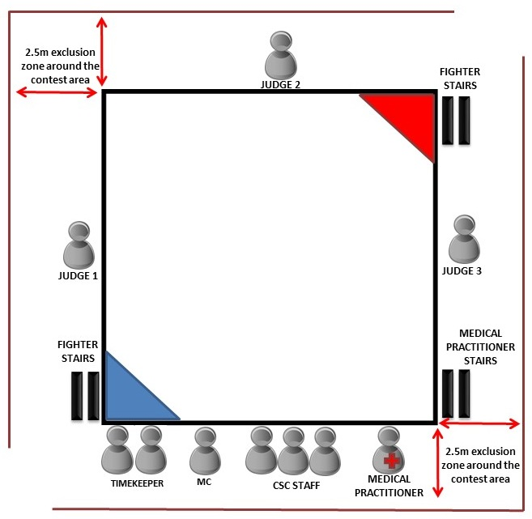

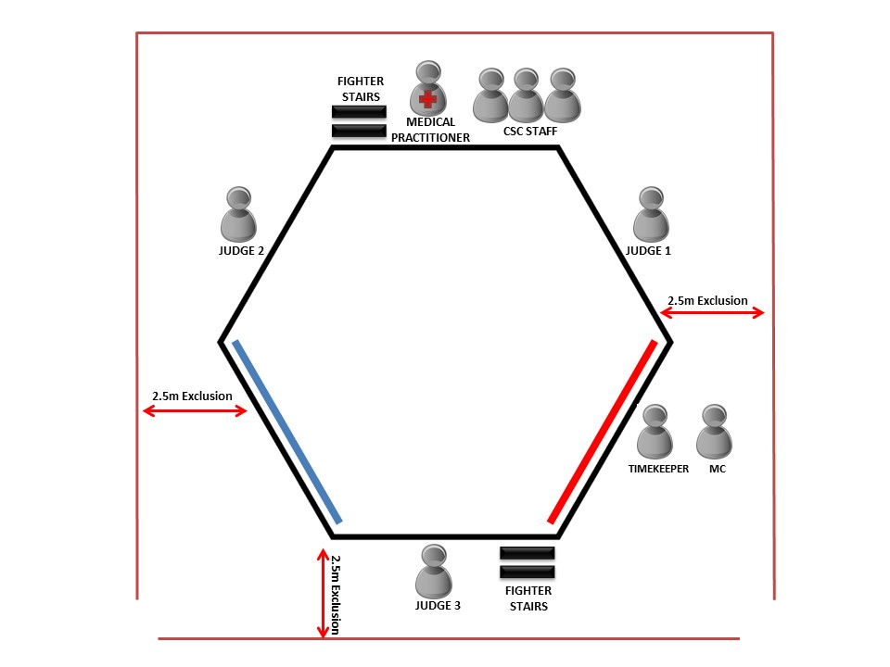
- Standard Hexagonal Enclosure Layout

- Standard Octagonal Enclosure Layout
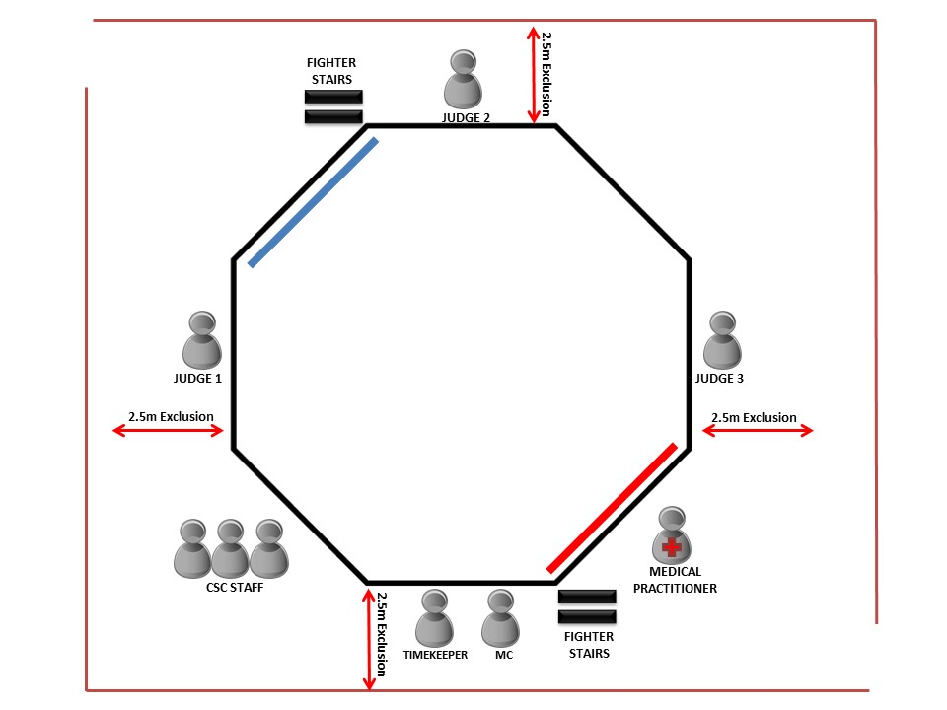

- Standard Circular Enclosure Layout
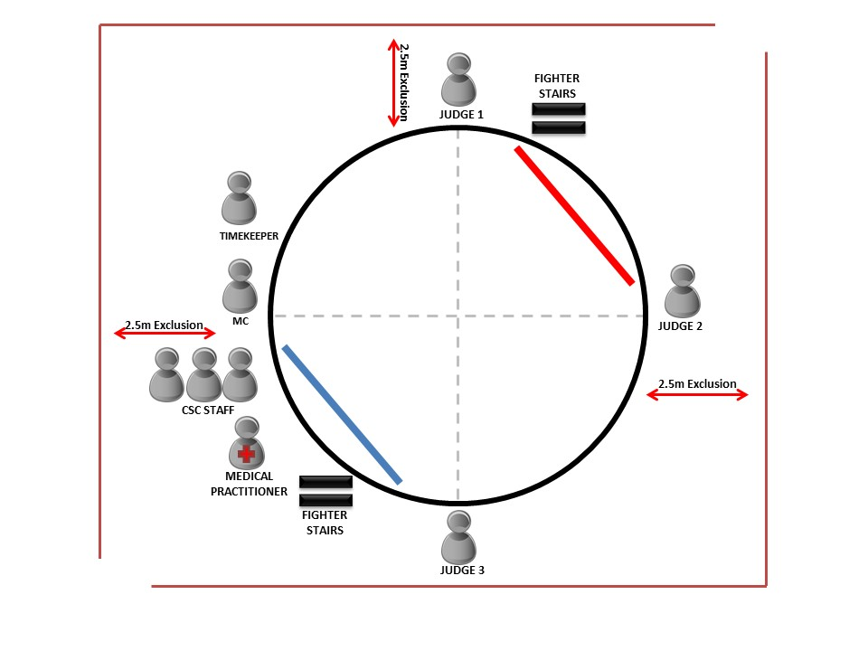

- Sample Mixed Martial Arts Scorecard

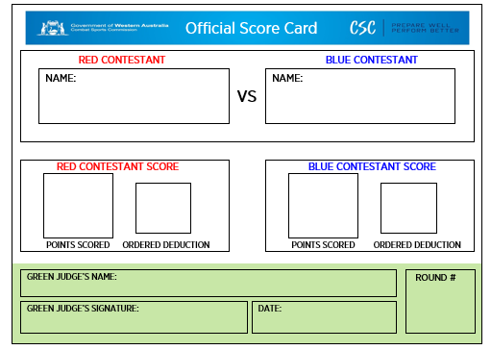

Part 8 - Breaches

- These Rules as developed by the Commission In accordance with section (10)(b) of the Act and approved by the Minister pursuant to section 62A of the Act apply to every industry participant who takes part in any event or any other proceeding or matter purporting to be conducted under or which is governed by the Rules.
- Any breach of the Rules will be subject to the relevant disciplinary provisions of the Act and Commission’s Code of Conduct.

Part 9 - Summary

- All Contestants and Industry Participants are required to:
- Prepare as safely as possible for a contest.
- Understand the rules of a contest.
- Ensure that they understand their duties as responsibilities at a weigh in and a contest.
- Ensure that they are free from alcohol and illicit substances.
- Obey the commands of the Referee, the Medical Practitioner and the Commission Representative(s) at all times and understand that their decision is final.
- Understand that they are responsible for their behaviour and adhere to the Commissions Code of Conduct at all times.

