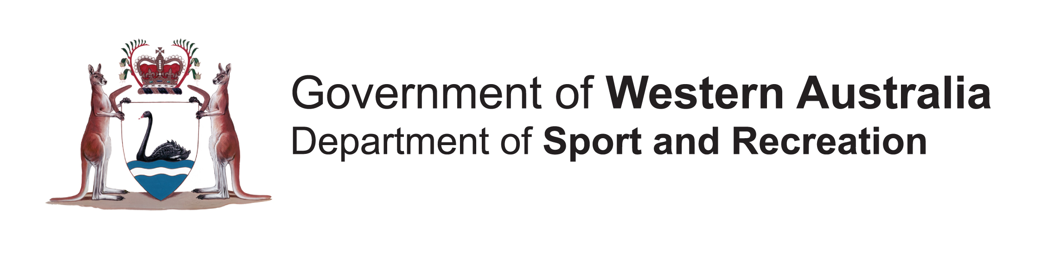

President/Chairperson

The President is the principle leader of the ______________ club/group and has overall responsibility for the ______________club’s/group’s administration.

The President sets the overall annual committee agenda (consistent with the views of members), helps the committee prioritise its goals and then keeps the committee on track by working within that overall framework. At the operational level, the major function of the President is to facilitate effective committee meetings.

Responsible To

The President is elected by the ______________members and responsible for representing the views of the ______________members.

Responsibilities and Duties

The President/Chairperson should:
- Manage committee and/or executive meetings
- Manage the annual general meeting
- Represent the club/group at local, regional, state and national levels
- Act as a facilitator for club/group activities
- Ensure the planning and budgeting for the future is carried out in accordance with the wishes of the members.

Knowledge and Skills Required

Ideally the President/Chairperson is someone who:
- Can communicate effectively
- Is well informed of all organisation activities
- Is aware of the future directions and plans of members
- Has a good working knowledge of the constitution, rules and the duties of all office holders and subcommittees
- Is a supportive leader for all organisations members.

Estimated Time Commitment Required & Period of Appointment

The estimated time commitment required as the President/Chairperson of ______________ is ______________hours per week.

(The time commitment required as the President/Chairperson of a club/group varies greatly from club/group to club/group. Smaller clubs may require a President to spend only a half hour to an hour per week or larger clubs two to three hours per week on Presidential duties.)

The President is appointed for a ______________term.

