Insert School Name Here

Add School Logo

Year 6 Camp

Month Year

Ern Halliday Recreation Camp

Name: _________________________________

Do you?
(Pre-camp Self assessment)

The following statements reflect on your behaviour and actions before camp. Please answer the following “Do you” questions by colouring in the smiley faces:

1= never, 2 = sometimes and 3 = always.

1. Support and encourage others?

2. Provide positive feedback to classmates?

3. Help others express their views?

4. Ask of others ideas and opinions?

5. Share your ideas to the group?

6. Listen to others ideas and opinions?

7. Do respect others ideas and opinions?

8. Discuss conflicting views in a friendly manner?

9. Wait your turn in activities?

10. Care for others well-being?

11. Give others an equal chance to have a turn?

12. Attempt new things?

13. Help others?

14. Are considerate of others feelings and emotions?

15. Think about what you say prior to speaking?

16. Plan or think before acting?

17. Reflect on your actions?

18. Feel that you are organised?

Camp Rules

Please take the time to put together some rules for your camp so it will be a successful and memorable time for all.

1.

2.

3.

4.

5.

6.

7.

8.

9.

10.

What do I need to bring to camp?

Personal goals for camp

In the space below please write your personal goals that you would like to achieve on camp.

- ______________________________________________________________

- ______________________________________________________________

- ______________________________________________________________

- ______________________________________________________________

- ______________________________________________________________

Time | Date: | Date: | Date:
6.00
7.00
8.00
9.00
10.00
11.00
12.00
13.00
14.00
15.00
16.00
17.00
18.00
19.00
20.00
21.00
22.00
Camp Timetable
Your day….

Briefly outline the most significant part of your day.

___________________________________________________________________

___________________________________________________________________

___________________________________________________________________

___________________________________________________________________

Why was this so significant?

___________________________________________________________________

___________________________________________________________________

Explain three (3) things you learnt from this experience

- ________________________________________________________________

___________________________________________________________________

- ________________________________________________________________

___________________________________________________________________

- ________________________________________________________________

___________________________________________________________________

Challenge….

Camp is all about meeting challenges. This may involve a personal or team challenge in which may extend you out of your comfort zone. Please answer the following questions in regards to challenges at camp.

Outline a situation where you where challenged today.

___________________________________________________________________

___________________________________________________________________

___________________________________________________________________

___________________________________________________________________

What made the situation challenging?

___________________________________________________________________

___________________________________________________________________

___________________________________________________________________

How were you affected by the challenge? (Feelings and/or emotions)

___________________________________________________________________

___________________________________________________________________

___________________________________________________________________

Did you overcome the challenge? Why or why not?
___________________________________________________________________

___________________________________________________________________

___________________________________________________________________

Communication….

Effective communication is an important part of daily life. Being clear and understood, limiting conflict, listening to others, expressing your ideas or views and holding conversations all play part it being a strong communicator.

Outline a situation where you used your communication skills today.

___________________________________________________________________

___________________________________________________________________

___________________________________________________________________

___________________________________________________________________

How do you rate your communication skills in this situation? What did you do well and how did you know you were understood?

___________________________________________________________________

___________________________________________________________________

___________________________________________________________________

What would you do better?

___________________________________________________________________

___________________________________________________________________

___________________________________________________________________

What else did you learn from this experience?

___________________________________________________________________

___________________________________________________________________

___________________________________________________________________

Positive versus negative…..

Outline a positive moment for you in your day.

___________________________________________________________________

___________________________________________________________________

___________________________________________________________________

Why was this moment positive?

___________________________________________________________________

___________________________________________________________________

___________________________________________________________________

Outline a negative moment in your day.

___________________________________________________________________

___________________________________________________________________

___________________________________________________________________

Why was this moment negative?

___________________________________________________________________

___________________________________________________________________

___________________________________________________________________

What did you learn about yourself in one of these experiences?

___________________________________________________________________

___________________________________________________________________

___________________________________________________________________

Working with others….

Working with others is an important part of school, team sports and friendships. Working together, limiting conflict, sharing responsibility, meeting task responsibilities, listening to others, being supportive and encouraging and limiting negative judgements are all skills that are needed to effectively work with others.

Outline a situation where you worked well with others today.

___________________________________________________________________

___________________________________________________________________

___________________________________________________________________

___________________________________________________________________

Why would you say you worked well with others? What did you contribute to the group?

___________________________________________________________________

___________________________________________________________________

___________________________________________________________________

What would you do better?

___________________________________________________________________

___________________________________________________________________

___________________________________________________________________

What are the rewards for working well with others?

___________________________________________________________________

___________________________________________________________________

___________________________________________________________________

Did you?
(Post camp questionnaire)

The following statements reflect on your behaviour and actions during camp. Please answer the following “Did you” questions by colouring in the smiley faces:

1= never, 2 = sometimes and 3 = always.

1. Support and encourage others?

2. Provide positive feedback to classmates?

3. Help others express their views?

4. Ask of others ideas and opinions?

5. Share your ideas to the group?

6. Listen to others ideas and opinions?

7. Respect others ideas and opinions?

8. Discuss conflicting views in a friendly manner?

9. Wait your turn in activities?

10. Care for others well-being?

11. Give others an equal chance to have a turn?

12. Attempt new things?

13. Help others?

14. Are considerate of others feelings and emotions?

15. Think about what you say prior to speaking?

16. Plan or think before acting?

17. Reflect on your actions?

18. Feel that you were organised?

Did your behaviour and actions change over camp? ____________________________________

Do you think camp will change your actions and behaviour in the future? Why or why not?

______________________________________________________________________________

______________________________________________________________________________

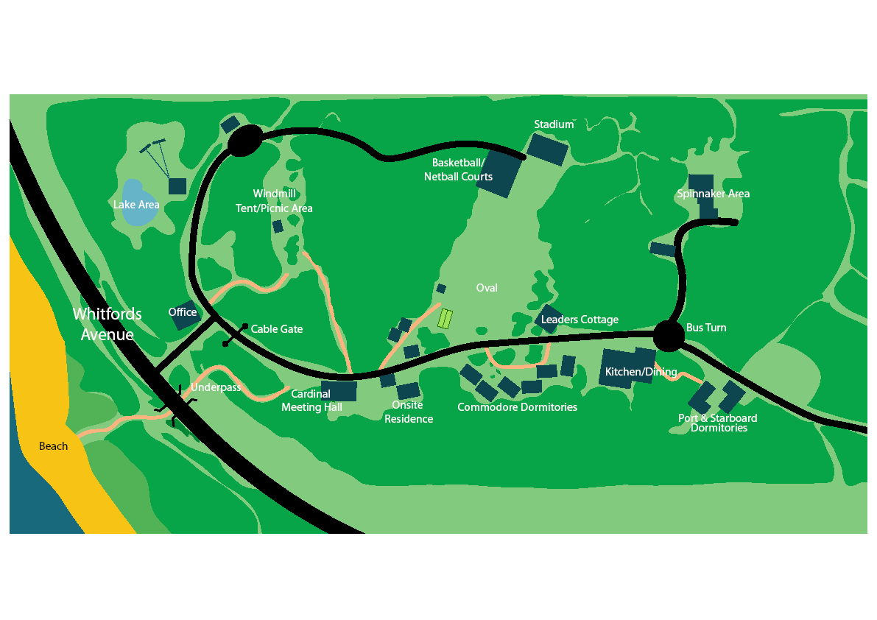
N
Ern Halliday Recreation Camp

