Strategic Funding Review Response to Preliminary Findings
Executive Summary
This document details industry and stakeholder feedback to the draft findings and recommendations developed as part of the extensive consultation process involving the Strategic Funding Review.
Those interim findings and recommendations were first outlined in the Preliminary Findings report released in January 2019.
The feedback to the 22 findings and 12 recommendations is one of general support and confirmation. A detailed summary of the survey results is provided as Attachment 1.
Fourteen of the 22 findings recorded no level of disagreement through the survey process. In effect, this indicates there was unanimous support for those 14 findings.
The highest supported findings were:
% of Strongly Agree responses | Finding
66% | The industry’s view of itself is to provide participation opportunities, build the capacity of the sport and to ensure it is well governed.
66% | There should be transparency and accountability in how the funding for the Industry Investment Program (IIP) is allocated.
61% | The department and the industry need to engage more effectively with the health and education sectors.
58% | The department needs to continue to build the capacity and capability of organisations, recognising there is significant variation within the industry. How this occurs may require a different approach and relationship with the industry, including greater engagement and partnerships.
56% | The investment in sport and recreation organisations has made a difference to the industry either to ensure that operations continue or to improve the professionalism of an organisation.
56% | Local government is a major player in community sport and recreation and needs to be factored into the traditional delivery model.

In relation to the recommendations, there was an extremely high level of support ranging from 93% support for Recommendation 2 (The Industry Investment Program to have three-year funding blocks, with an annual assessment. Each organisation will be determined to fit a category based on their capability and capacity.) to 53% for Recommendation 3 (All organisations’ Industry Investment Program allocation for the 2019-20 financial year will be reset to the base funding level of the category. There will be a 12-month transition period until new funding allocations are implemented where changes result in a decrease of funding).
Seven of the 12 recommendations attracted some level of negative feedback, generally 2.5% of all responses. There were three exceptions being:
- Recommendation 3 had the highest level of negative feedback with 8% unsupportive and 5% strongly unsupportive of the recommendation, though no specific comments were provided;
- Recommendation 7 (The department to host a leadership forum between local governments and State Sporting Associations to discuss the roles and responsibilities of club development.) also recorded negative feedback: 5% strongly unsupported and 2.5% unsupported. Though the comments provided did not reflect this score and reinforced the need for the work to occur; and
- Recommendation 5 (The department undertakes a health check of the Every Club program to make refinements for any future funding rounds.) had 2.5% unsupported and 2.5% strongly unsupported.
The highest supported recommendations were:
% of Support | Recommendation
93% | Rec 2:  The Industry Investment Program to have three-year funding blocks, with an annual assessment. Each organisation will be determined to fit a category based on its capability and capacity.
82% | Rec 11:  A mid-tier events strategy will be developed to fund metropolitan and regional sporting events.  Rec 1:  The department to publish the Industry Investment Program categorisation criteria for State Sporting Associations for review by the industry before implementation in 2019-20. This will include the category’s eligibility to apply for other funding programs and will outline other policy requirements, i.e. gender targets.  Rec 8:  The department will implement a pilot to trial alternative models of support for kids to access sport in targeted regional and remote locations where the KidSport model is not suitable.
76% | Rec 4:  Regional Organisation Grants and Regional Servicing Grants will be consolidated within the Industry Investment Program.  Rec 6:  The department develops an implementation strategy for Every Club (including stakeholder consultation and communications plan) based on the previous work undertaken by the department which examined the roles and responsibilities for club development in Western Australia.  Rec 9:  The department will undertake a review of the KidSport program in 2019-20 to examine the impact of policy changes that were enforced in 2017 and 2018.  Rec 10:  The Active Regional Community Grants program to be more widely promoted and an increase in funding to the pool is being considered

In relation to the IIP categorisation criteria, the feedback will be considered in the finalisation of the review. The amount of feedback was not as extensive as was anticipated.
Overall, it would appear that the Preliminary Findings and recommendations reflect the feedback from the consultation process in October-December last year. There would also seem to be a recognition of the change of process implemented by the department with 67% of respondents indicating that they were either very or extremely satisfied with the consultation process.
There is room for improvement with 5% being only slightly satisfied or not at all satisfied with the process. The remainder were moderately satisfied.
With the feedback now provided, the department will finalise the associated funding implications and implementation strategy for release in May 2019.

Preliminary Findings Consultation Process
The consultation process for this part of the review occurred over a six-week period and was a combination of workshops, survey and written responses.
Workshops were held in Geraldton and Bunbury, with WA Sports Federation (WASF) and Parks and Leisure Australia (PLA WA) each hosting a workshop in the metropolitan area. The department also briefed the Strategic Funding Review Reference Group and the WASF Board.
The purpose of the workshops was to outline the findings and recommendations contained within the Preliminary Findings document to gauge the reactions of the participants. The overall feedback was positive, with participants encouraged to provide further feedback via the survey or as written responses to the findings document. Overall, 100 people participated in this component of the consultation.
The survey was also developed to gauge views on the findings and recommendations. In addition, for organisations that receive Industry Investment Program (IIP) funding, there were additional questions pertaining to the categorisation criteria in Attachment 2 of the Preliminary Findings document. The survey was issued to all registered participants in the initial workshops (held October-December 2018) and all recipients of IIP. The survey closed on 21 March 2019 and had a 37% response rate.
The survey also provided respondents the opportunity to:
- outline any ideas or findings that the department might have missed
- provide additional comments regarding the IIP categorisation criteria
- provide an opportunity for final comments
- indicate their level of satisfaction with the consultation process.

In addition, written responses were received from the following organisations:
- Swimming WA
- City of Rockingham
- PLA WA
- Westcycle
- Masters Swimming
- Softball WA.
This feedback is reflected in the body of the report, with Attachment 1 providing a summary of the findings and comments relating to the survey.

Requirements for Finalisation of the Review
As a result of the feedback to the Preliminary Findings document, including the recommendations and feedback to the categorisation criteria, there is a need for additional work before the review can be finalised.
Finalisation and Implementation of the Findings
The following findings require further work and the development of an implementation strategy. These are likely to generate ongoing work through 2019-20 and beyond.
- Finding 4: There is a wide range of expectations of the role of the department in supporting the industry, with a shift of focus towards facilitating outcomes rather than leading the delivery.
- Finding 11: There should be transparency and accountability in how the funding for the Industry Investment Program is allocated.
- Finding 15: The department and the industry should work with Sport Australia to help simplify compliance and industry standards, and for the National Sporting Organisations to assist Western Australian State Sporting Associations
- Finding 18: The department should investigate the process of developing a universal unit of measurement for the sport and recreation industry.
The following findings need consideration for a greater explanation or change to wording;
- Finding 9: The WA Sports Federation should strengthen its role as the peak advocacy body for sport to be expanded to include all peak bodies for their respective areas.
- Finding 14: The department should provide online best practice guidance — including templates, policies and procedures — for State Sporting Associations to be amended to look at the deletion of the department.
Further work is required with the industry as to the priority and actions associated with the findings, that do not have a corresponding recommendation. This work is to be detailed in the Implementation Strategy and the following will need to be completed by May for inclusion in the Final Report:
- internal review
- feedback on the amended changes through the Reference Group
- endorsement process through WASF and where appropriate additional peak bodies.

Finalisation and Implementation of the Recommendations
The following recommendations require further work and the development of an implementation strategy. These are likely to generate ongoing work through 2019-20 and beyond.
- Recommendation 3: All organisations’ Industry Investment Program allocation for the 2019-20 financial year will be reset to the base funding level of the category. There will be a 12-month transition period until new funding allocations are implemented where changes result in a decrease of funding.
- Recommendation 4: Regional Organisation Grants and Regional Servicing Grants will be consolidated within the Industry Investment Program.
- Recommendation 10: The Active Regional Community Grants program to be more widely promoted and an increase in funding to the pool is being considered.
- Recommendation 11: A mid-tier events strategy will be developed to fund metropolitan and regional sporting events.
- Recommendation 12: An innovation funding pool will be explored to provide responsive funding to challenges and trends. This will be progressed through a Request for Proposal process in response to developing trends and initiatives.
The following recommendations need consideration for a greater explanation or change of wording:
- The sequence of the Every Club recommendations to be reversed.
This work is to be detailed in the Implementation Strategy and the following will need to be completed by May for inclusion in the Final Report:
- internal review
- feedback on the amended changes through the Reference Group
- endorsement process through WASF and PLA WA and where appropriate additional peak bodies.

Finalisation and Implementation of the IIP Categorisation Criteria
This work is to be detailed in the Implementation Strategy and the following will need to be completed by May for inclusion in the Final Report:
- internal review
- feedback on the amended changes through the Reference Group
- endorsement process through WASF and PLA WA and where appropriate additional peak bodies
- republish the categorisation tables
- publish the IIP funding bands and increments
- department staff to meet with the CEO and Chair of any organisations that will receive notice of a potential change in funding occurring in 2020-21, to outline steps that can be made by the organisation to improve its position.

Summary of the feedback to the Preliminary Findings
Overall, the findings have a high level of support — with an average of 82.5% support — and no finding having less than a 64% level of agreement.
The feedback includes:
Finding 2 (There is room for improvement in terms of the tailoring requirements for smaller organisations and continuing to review what core business is.) had 100% support (47% strongly support and 53% support).
Finding 18 (The department should investigate the process of developing a universal unit of measurement for the sport and recreation industry) had the lowest support rating at 64% and the highest neutral response at 31%, there needs to be further work to assess how this is implemented, including the timeframe.
The highest supported findings were:
% of Strongly Agree responses | Finding
66% | The industry’s view of itself is to provide participation opportunities, build the capacity of the sport and to ensure it is well governed.
66% | There should be transparency and accountability in how the funding for the Industry Investment Program is allocated.
61% | The department and the industry need to engage more effectively with the health and education sectors.
58% | The department needs to continue to build the capacity and capability of organisations, recognising there is significant variation within the industry. How this occurs may require a different approach and relationship with the industry, including greater engagement and partnerships.
56% | The investment in sport and recreation organisations has made a difference to the industry either to ensure that operations continue or to improve the professionalism of an organisation.
56% | Local government is a major player in community sport and recreation and needs to be factored into the traditional delivery model.

There were also responses where there was a disagreement to the finding, while the highest level of disagreement was 5%, it does signal that ongoing engagement and work is required. The findings where there was a 5% level of disagreement recorded, including strong disagreement, were:
Findings with up to a 5% level of disagreement
Finding 13: The department should progress the development of a consolidated funding agreement with each State Sporting Association and Industry Recognised Organisation.
Finding 14: The department should provide online best practice guidance — including templates, policies and procedures — for State Sporting Associations.
Finding 17: The department should consider adopting a whole-of-government language common to the health and education sectors
Finding 20: There is a point of difference between regional and metropolitan participants as to the value of investing in the traditional delivery model.

The following are those findings where any level of disagreement was lodged.
Findings
There is a wide range of expectations of the role of the department in supporting the industry, with a shift of focus towards facilitating outcomes rather than leading the delivery.
The WA Sports Federation should strengthen its role as the peak advocacy body for sport.
The department and the industry should work with Sport Australia to help simplify compliance and industry standards, and for National Sporting Organisations to assist Western Australian State Sporting Associations.
The department should investigate the process of developing a universal unit of measurement for the sport and recreation industry.

This means that 14 of the 22 findings recorded no level of disagreement. In effect, this indicates there was unanimous support for those 14 findings.
In addition to the scoring responses, there was also the opportunity for written responses to be provided to provide context to the score. Attachment 1 provides a summary of the comments provided. Comments where the response was a single word (yes, no or n/a) have not been included. In addition, where the comment identifies an organisation, that identifier has also been removed.
The following section represents the feedback to the themes.
Summary of the Findings — are the department’s funding programs appropriate to make a difference to the industry?
The three findings associated with this theme were highly supported with the following scores:
 | Finding | Supported | Neutral | Disagree
1 | The investment in sport and recreation organisations has made a difference to the industry either to ensure that operations continue, or to improve the professionalism of an organisation. | 95 | 5
2 | There is room for improvement in terms of the tailoring requirements for smaller organisations and continuing to review what their core business is. | 100
3 | Further work is required to review the appropriateness of funding programs against the department’s outcomes and state government priorities | 84 | 13 | 3

Within the feedback, there was a range of views expressed suggesting areas where further work could occur. Many of the observations reflected the circumstances of the respondent as to whether the focus should be on smaller organisations, recreation or local government.
However, the level of support suggests that the findings as currently described are appropriate. There may need to be subsequent work to articulate the state government priorities, given the extent of neutral responses.
Summary of the Findings — Define and Deliver Core Business
The six findings associated with this theme had a variety of support with the following scores:
 | Findings | Supported | Neutral | Disagree
4 | There is a wide range of expectations of the role of the department in supporting the industry, with a shift of focus towards facilitating outcomes rather than leading the delivery. | 76 | 21 | 3
5 | The department needs to continue to build the capacity and capability of organisations, recognising there is significant variation within the industry. How this occurs may require a different approach and relationship with the industry, including greater engagement and partnerships. | 97 | 3
6 | The industry’s view of itself is to provide participation opportunities, build the capacity of the sport and to ensure it is well governed. | 94 | 6
7 | There is a need for the sport and recreation industry to evaluate its relationship with the department in order to ensure the correct roles and responsibilities are in place. | 92 | 8
8 | The department and the industry need to reposition relationships to work more collaboratively (as has occurred through this process). | 87 | 13
9 | The WA Sports Federation should strengthen its role as the peak advocacy body for sport. | 79 | 18 | 3

The commentary in the feedback highlighted that there are different requirements for small and large organisations and, as a result, the perceived role of the department is also different. There is a need for balance in determining the role the department plays, particularly for smaller organisations.
Some of the comments look to raise questions including whether Finding 9 relates to all peak bodies and not just the WASF for sport. In relation to WASF, it was suggested that because of the current funding relationship there might be a fear of possible retribution for “taking the government to task”. There was also support for all peak bodies to strengthen their advocacy roles, noting that this may require a review of resourcing requirements and longer-term support.
Concerns were also raised that this is predominantly sport focused, and that recreation and leisure need to be included.
The level of support suggests that the findings as currently described are appropriate, with potential expansion of the wording in Finding 9 to include other peak bodies. While Findings 4 and 9 are significantly less supported, the commentary suggests that the feedback to Finding 4 requires ongoing work; and that Finding 9 could be more supported if it were expanded to outline similar statements for the other peak bodies including PLA WA, Outdoors WA and LIWA.
Summary of the Findings — Customisation of Approach
The two findings associated with this theme were highly supported with the following scores:
 | Finding | Supported | Neutral | Disagree
10 | There is a need to consistently customise the requirements of organisations across all grant programs, to reflect their capacity, capability and reach, and reflect the level of funding. | 90 | 10
11 | There should be transparency and accountability in how the funding for the Industry Investment Program is allocated | 93 | 7

There were limited comments provided in response to these findings. As a result, it is considered that that the findings as currently described are appropriate. One of the observations made in relation to Finding 11 is that there are some commercial in confidence elements that must be considered. This was written from the perspective of the department revealing how organisations spend their IIP allocation. But the intent of the finding was for the department to have greater transparency for the industry to understand how the funding is allocated.

Summary of the Findings — Simplifying Processes and Minimising Effort
The four findings associated with this theme were supported with the following scores:
 | Finding | Supported | Neutral | Disagree
12 | The department should look at standardising the application and acquittal process for programs with aligned funding outcomes. | 92 | 8
13 | The department should progress the development of a consolidated funding agreement with each State Sporting Association and Industry Recognised Organisation. | 87 | 8* | 5
14 | The department should provide online best practice guidance including templates, policies and procedures for State Sporting Associations. | 80 | 15* | 5
15 | The department and the industry should work with Sport Australia to help simplify compliance and industry standards, and for National Sporting Organisations to assist Western Australian State Sporting Associations. | 79 | 18* | 3
*indicates that there was a “not applicable” result included in the total
This theme had numerous “not applicable” responses. The predominant theme in the commentary related to the developments by Sport Australia and concerns that national organisations pursuing a unitary model or one management governance model. This will represent a considerable work focus for the industry and the department over the coming 12 months.
There were also comments supporting the standardisation of processes acknowledging that there is significant work involved to consider the varying capacities and capabilities of the industry.
Also, there were comments as to how SSAs could work more productively with local governments in the development of their strategic plans.
One of the observations made in relation to Finding 14 is that this does not necessarily need to be a department-driven outcome. This matter has also been discussed during the workshops and may require an adjustment to the wording. Therefore, based on this comment and in response to these findings as a result it is considered that the findings as currently described are appropriate, noting the wording for Finding 14 may need to be amended.

Summary of the Findings — How does the Sport and Recreation sector engage with the Health and Education sectors in a more Meaningful Way?
Support for the three findings associated within this theme varied, with the following scores:
 | Finding | Supported | Neutral | Disagree
16 | The department and the industry need to engage more effectively with the health and education sectors. | 97 | 3
17 | The department should consider adopting a whole-of-government language, common to the health and education sectors. | 82 | 13 | 5
18 | The department should investigate the process of developing a universal unit of measurement for the sport and recreation industry. | 64 | 33* | 3
*indicates that there was a “not applicable” result included in the total
The comments provided reflect the discussions in the workshops and the process to date. Put simply, it is how this will be achieved that is of most concern. Comments provided include:
- This has been a long time coming and recognition from the health and education sector of the importance of the physical and mental well-being provided by the sport and recreation industry should be promoted. Therefore, it would make sense to use the same terminology and measures for reporting.
- An impossibility that would simply promote unsubstantiated guess work by the SSA, with little or no factual supporting evidence. Pure recreation should not be included in any formal SSA calculations regarding sport.
- Health and education are a significant sector. However, local government, tourism, transport and treasury among others have impacts. It is more appropriate for government to adopt a "common community language" that allows greater engagement and clarity.
This level of feedback has resulted in the clear support for the concept as articulated in Finding 16 with less certainty in the implementation as seen in Findings 17 and 18. There is a significant amount of work required over the long term to realise these findings and this will require a separate process. However, based on the response to these findings it is considered that the findings as currently described are appropriate.
Summary of the Findings — Participation in a Changing Environment
The four findings associated with this theme were supported with the following scores:
 | Finding | Supported | Neutral | Disagree
19 | The expansion of the definition of sport at a federal level to include physical activity needs to be reviewed at a State level with a position statement considered. | 82 | 15 | 3
20 | There is a point of difference between regional and metropolitan participants as to the value of investing in the traditional delivery model. | 82 | 13* | 5
21 | Local government is a major player in community sport and recreation and needs to be factored into the delivery model. | 89 | 8* | 3
22 | There are market gaps in how the department supports events, participation and active recreation opportunities. | 82 | 18
*indicates that there was a “not applicable” result included in the total
The comments provided in response to the survey varied and appear to reflect the current relationship that the respondent has either with their counterpart (local government for sport and vice versa). As a result, it highlights that there is a divide and a requirement for further work to occur.
Some of the comments acknowledge that there is work to be done to develop and strengthen these discussions. Based on the scores and the feedback, it is considered that the findings as currently described are appropriate.

Summary of the Findings — Any Findings or Ideas we Might have Missed?
There is a wide range of comments provided, some of these will need to be considered in the context of the Implementation Strategy, where several findings are not tied to any recommendations. Some of these ideas may result in new strategies to be considered. The ideas and feedback are summarised below:
- Lack of appreciation for the importance of funding core business whilst at the same time, expecting more governance and compliance. The National Redress Scheme (for example) will have an enormous impact on sport administrators and result in less emphasis on program delivery and more focus on bureaucracy.
- Lack of recognition of SSAs which have followed the cues from the government to become more self-sufficient financially.
- How to support the Over 55s, with the vast majority of programs targeted at junior groups.
- Local councils need to be more proactive in supporting SSAs operating in their jurisdictions.
- Participants in sport travel through a revolving door. There is a constant and consistent need for new members. A strong focus and funding focus should be on encouraging participation through grass roots mechanisms.
- Clarification on the impact of funding after the sale of the TAB.
- Gender equality on boards and being able to attract volunteers to nominate.
- VenuesWest’s fee structure for sports associations and clubs. This cost element does not assist amateur sports to be self-sufficient and in the hosting of events.
- WAIS and the amount of funding it receives.
- Sport in competition with government entities.

Summary of the Feedback to the Recommendations
The recommendations had an extremely high level of support, ranging from 93% support for Recommendation 2 to 53% for Recommendation 3 (All organisations’ Industry Investment Program allocation for the 2019-20 financial year will be reset to the base funding level of the category. There will be a 12-month transition period until new funding allocations are implemented where changes result in a decrease of funding.).
The highest supported recommendations were:
% of Support | Recommendation
93% | Rec 2:  The Industry Investment Program to have three-year funding blocks, with an annual assessment. Each organisation will be determined to fit a category based on its capability and capacity.
82% | Rec 11:  A mid-tier events strategy will be developed to fund metropolitan and regional sporting events.  Rec 1:  The department to publish the Industry Investment Program categorisation criteria for State Sporting Associations for review by the industry before implementation in 2019-20. This will include the category’s eligibility to apply for other funding programs and will outline other policy requirements, i.e. gender targets.  Rec 8:  The department will implement a pilot to trial alternative models of support for kids to access sport in targeted regional and remote locations where the KidSport model is not suitable.
76% | Rec 4:  Regional Organisation Grants and Regional Servicing Grants will be consolidated within the Industry Investment Program.  Rec 6:  The department develops an implementation strategy for Every Club (including stakeholder consultation and communications plan) based on the previous work undertaken by the department which examined the roles and responsibilities for club development in Western Australia.  Rec 9:  The department will undertake a review of the KidSport program in 2019-20 to examine the impact of policy changes that were enforced in 2017 and 2018.  Rec 10:  The Active Regional Community Grants program to be more widely promoted and an increase in funding to the pool is being considered

Seven of the 12 recommendations attracted some negative feedback, generally 2.5% of all responses. There were three exceptions:
- Recommendation 3 had the highest level of negative feedback with 8% unsupportive and 5% strongly unsupportive of the recommendation, though no specific comments were provided. In the absence of the funding bands being provided, there is a high probability that this was to counter an anticipated decrease in the funding to be announced.
- Recommendation 7 (The department to host a leadership forum between local governments and State Sporting Associations to discuss the roles and responsibilities of club development.) also recorded negative feedback, with 5% strongly unsupported and 2.5% unsupported. However, the comments provided did not reflect this score and reinforced the need for the work to occur.
- Recommendation 5 (The department undertakes a health check of the Every Club program to make refinements for any future funding rounds.) had 2.5% unsupported and 2.5% strongly unsupported. Comments made were supportive of a review, as long as it was transparent.
As per the findings, with the scoring responses there was also the opportunity for respondents to provide written responses to give context to the score. Attachment 1 provides a summary of the comments provided. Comments where the response was a single word (yes, no or n/a) have not been included. In addition, where the comment identifies an organisation that identifier has also been removed.

Industry Investment Program
The four recommendations associated with this program had varied degrees of support, with the following scores:
 | Recommendation | Supported | Neutral | Disagree
1 | The department to publish the Industry Investment Program categorisation criteria for State Sporting Associations (Appendix B) for review by the industry before implementation in 2019-20. This will include the category’s eligibility to apply for other funding programs and will outline other policy requirements, i.e. gender targets. | 87 | 13*
2 | The Industry Investment Program to have three-year funding blocks, with an annual assessment. Each organisation will be determined to fit a category based on their capability and capacity. | 93 | 7*
3 | All organisations’ Industry Investment Program allocation for the 2019-20 financial year will be reset to the base funding level of the category. There will be a 12-month transition period until new funding allocations are implemented where changes result in a decrease of funding. | 53 | 33* | 14
4 | Regional Organisation Grants and Regional Servicing Grants will be consolidated within the Industry Investment Program. | 76 | 21* | 3
*indicates that there was a “not applicable” result included in the total
The comments provided indicated strong support for the return to the three-year funding arrangement. However, as there has been no confirmation to the amounts of funding associated with each category, there is less support for Recommendation 3. Also, there is a degree of neutrality in this response as a result of not knowing whether the changes are a good or a bad thing for the sport.
There is also uncertainty as to what the consolidation of the regional funding means for the current recipients and as it is not widely known.
The detailed commentary regarding Recommendation 1 is considered in a separate section of the report.
One aspect that will require further work is to address the question of funding for peak bodies and Industry Representative Organisations and to clarify the role and eligibility of Sport and Recreation Agents.
While there is still considerable work to be done to finalise the funding, based on the scores and the feedback it is considered that the recommendations as currently described are appropriate.

Every Club
The three recommendations associated with this program were generally supported with the following scores:
 | Recommendation | Supported | Neutral | Disagree
5 | The department undertakes a health check of the Every Club program to make refinements for any future funding rounds. | 71 | 24* | 5
6 | The department develops an implementation strategy (including stakeholder consultation and communications plan) based on the previous work undertaken by the department which examined the roles and responsibilities for club development in Western Australia. | 76 | 21* | 3
7 | The department to host a leadership forum between local governments and State Sporting Associations to discuss the roles and responsibilities of club development. | 71 | 21* | 8
*indicates that there was a “not applicable” result included in the total
The comments provided are consistent with the feedback provided to the theme of participation in a changing environment. There is support for a health check so long as it is transparent and not a full-scale review. There is a disconnect between the role and responsibility of club development. Some of the most relevant comments provided include:
- Some local governments are severely under resourced in this area and there will need to be an agreement between those LGAs and the sporting bodies as to who is best placed to provide the service, particularly in some regional and rural areas. Some pressure may be required for LGA to improve their sport and recreation delivery and resourcing, particularly if it can be aligned with the health sector.
- Recommended that there is clear agreement on where the funds are used and the measures, e.g. what percentage of funds are invested at club level, State, national competitions? LGAs support of sports that do not have an associated SSA should also be quantified, particularly with the growth of unstructured, non-traditional sports.
- This would make a big difference in terms of a greater understanding from SSAs related to the limitations of local government and it is difficult at times to meet the constant demands from some sports to play all year round.
Based on the scores and the feedback it is considered that the recommendations as currently described are appropriate, though there may be benefit in reversing the sequence so that the forum occurs first.

KidSport
The two recommendations associated with this program were supported with the following scores:
 | Recommendation | Supported | Neutral | Disagree
8 | The department will implement a pilot to trial alternative models of support for kids to access sport in targeted regional and remote locations where the KidSport model is not suitable. | 81 | 19*
9 | The department will undertake a review of the program in 2019-20 to examine the impact of policy changes that were enforced in 2017 and 2018. | 76 | 21* | 3
*indicates that there was a “not applicable” result included in the total
The comments provided were limited and related to areas of the policy change. Based on the scores and the feedback, it is considered that the recommendations as currently described are appropriate.

Regional Based Program
The recommendation associated with this program were supported with the following score:
 | Recommendation | Supported | Neutral | Disagree
10 | The Active Regional Community Grants program to be more widely promoted and an increase in funding to the pool is being considered | 77 | 23*
*indicates that there was a “not applicable” result included in the total
The comments provided were that wider promotion would be positive, with a suggestion that the funding go to regional associations and not clubs. This may not represent the full intent of the program and will be reflected in the promotion process.
Based on the scores and the feedback, it is considered that the recommendations as currently described are appropriate.

New Funding Focus for 2019-20
The four recommendations associated with this program were supported with the following scores:
 | Recommendation | Supported | Neutral | Disagree
11 | A mid-tier events strategy will be developed to fund metropolitan and regional sporting events. | 82 | 18*
12 | An innovation funding pool will be explored to provide responsive funding to challenges and trends. This will be progressed through a Request for Proposal process in response to developing trends and initiatives. | 74 | 23* | 3
*indicates that there was a “not applicable” result included in the total
The comments provided reflect an assumption as to what these programs could be and were positive. As these ideas are further expanded, the comments provided in Attachment 1 will help inform the programs. Based on the scores and the feedback, it is considered that the recommendations as currently described are appropriate.

Summary of the Feedback to the IIP Categorisation Criteria
As part of the survey, organisations that receive IIP funding could submit feedback to the categorisation criteria. The section below is a summary of the comments provided in Attachment 1.
The survey sought to measure the organisations’ previous understanding of organisations of how the categories were determined, with the following results:

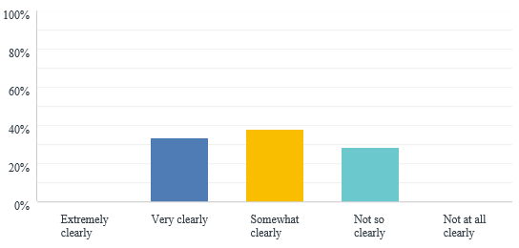
Following the release of the categorisation criteria, organisations were asked about their current understanding:
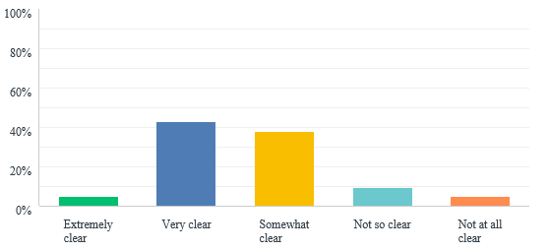
There is still room for improvement, but the combined scores of Extremely, Very, and Somewhat Clear increased from 72% to 85%.

Comments include:
Workforce
- There needs to be further discussion of the descriptions and numbers.
- Sport traditionally pays poorly, and we expect a lot from personnel. Tier C sports can't be expected to have full-time HR resources in place.
- The department will need to re-consider support in this area.
- No clear rating on a part-time workforce. These are usually an important component of the workforce with regard to club level development and engagement activities
Participation/Membership
- Tiers don't reflect WA sport. Too heavily weighted in lower tiers. For example, category C (20,000 members) is way too high.
- Very difficult to provide evidence-based statistics on participation, particularly in regional areas.
- This may change some levels if recorded differently from past years.
- Would agree with the ranges for each category.
High Performance/Pathways
- Not sure the descriptors are correct. Where is the emphasis on DTE, athlete retention, etc. Appears to be a high emphasis on events.
- HPP definition is clear in the detailed descriptors.
- No issues with categorisation.
Regional
- Communication and quality of data provided remains a significant challenge in regional areas.
- The model of a week-long and event-based series of activations is a model used by a number of sports to provide value in regional areas. This seems to be supported as long as it is a "plan". Confirmation that the model of engagement with a week-long regional engagement is suitable would assist
- Feel a % of total regions, probably 1-2 too high in the upper categories as some large sports have very few clubs in some regions.
Community Reach/programming
- Many of the comments indicated that SSAs are very good at this and should be funded and supported for bridging the “divide” between sport and participation.
- There was uncertainty as to what descriptors like "strong reach into community” means.
Governance
- An important, emerging requirement although care needs to be noted with a diminishing core of volunteers to carry out onerous governance requirements.
- General description and matrix approach are sound. Gender targets being arbitrary does not align with the actual principle of good governance if it is about "volunteer" boards with the correct skill matrix. This arbitrary direction is flawed in the principle of what governance is actually about, particular on unpaid volunteer boards which is what applies at sporting organisation level.
- Some guidelines and direction need to be distributed to those organisations that are looking to increase their gender equity on boards.
Finance
- Similar to membership; the weighting is incorrect. Category C seeks 20,000 members and yet the SSA only needs to turn over $750,000 to $1M. Surely, DLGSC wants to acknowledge and reward those SSAs who are attempting to secure their financial future and expand their sport, not penalise them.
- Matrix of financial value seems sound based on current understanding and feedback around the model.
- Seems fair in terms of bands.
Planning
- Many of the comments reflected the respondent’s current state of planning.
- Given the experience of DLGSC across multiple sporting associations, a template for a risk management matrix, asset management plan and workforce development plan would be extremely valuable, as these are tasks that are not always a primary skill set of boards or small operational management teams.

Any Additional Comments regarding the IIP Categorisation
There were several comments relating to the actual scoring process and whether there was any weighting applied to criteria. There was also a degree of caution expressed, waiting to see how the numbers “stacked-up” against the responsibilities demanded.

Final Comments and Satisfaction regarding the Consultation Process
Consultation Process
Within the survey, there was also an opportunity to indicate the level of satisfaction with the process — 67% indicated that they were either very or extremely satisfied with the consultation process. There is room for improvement, with 5% being only slightly satisfied or not at all satisfied with the process. The remainder were moderately satisfied.

Attachment 1 — Survey Responses and Summary
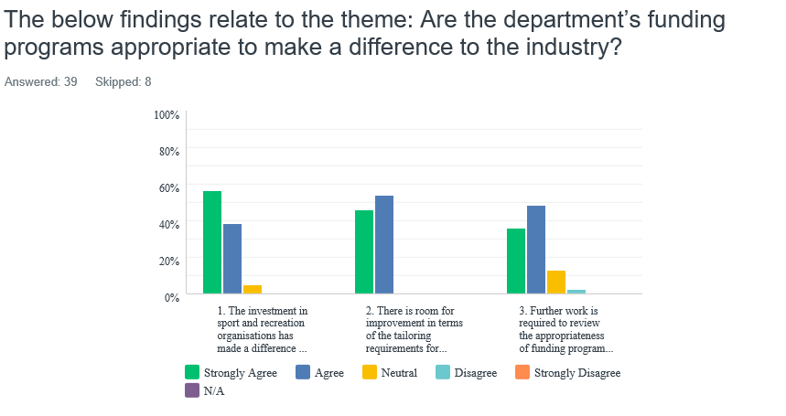
- Paper work for small organisation was over the top, seems to be improving with more tailored approach.
- Strongly agree we need to further define what the core business of the department is. (Who? What? How? Why?)
- It would appear that DLGSC does not trust all SSAs to fulfil their roles and obligations within the wider sporting environment.
- I think there are occasions throughout the year where tailoring a round of funding aimed specifically at small organisations would be supported. On many occasions, this is the difference between a club or group getting a program over the line or waiting another 12 months, by which time it is too late. Many times, organisations need that flexibility to gain advantage of circumstances that change so rapidly.
- Funding programs should recognise the collective investment and value add opportunities through combined State and local government investment. Facility standards imposed by peak sporting bodies on local clubs need to be discussed by industry prior to their imposition as this regularly results in expectations and demands on local government where participation should be the priority.
- 1. Without funding, many of the smaller organisations would not exist and if they did would provide a small fragment of their current service delivery. The "multiplier" effect where many SSAs, peak bodies and IROs through a relatively small investment engage hundreds and thousands of volunteers to delivery services should be noted. 2. There is strong agreement with the importance of data collection and sharing data. But the emphasis should be on the purpose, type, quality and quantity of data to be collected. Investment in technology and research is also required to support data collection. 3. The issue surrounding funding professional sport is contentious. Views from the workshops indicated there is a strong belief that a majority of investment should be aimed at community sport and recreation not professional and elite sport. Perhaps an infographic could provide a breakdown of the funding into various areas of investment to provide a better understanding to the industry, e.g. 10% professional sport, 50% community sport, 20% SSAs and peak bodies, etc. 4. The three-year funding agreements are required at a minimum to enable organisational stability and delivery beyond a 12-month period
- I believe the proposed inclusion of regional grants to an SSO IIP funding is a great concept.
- Less of a sport focus and more on recreation working better with the federal government in terms of funding programs.
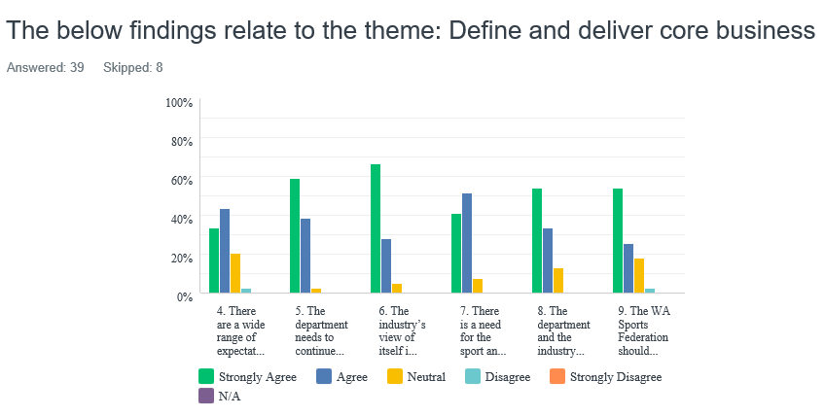

- Q9 deals with sport’s peak body. Will this include other peak bodies such as aquatic, Parks and Leisure?
- 6. Is it a role to provide High Performance? 7. Needs to be the converse (you engage with the industry).
- Significantly concerned by comments that some SSAs have been “over funded” in recent years. This indicates a lack of understanding of the SSA cohort by some DLGSC personnel.
- WASF role would be enhanced if it was reliant on funding from DLGSC. It feels that the fear retribution for taking government of the day to task because of funding arrangements.
- In my nine years at an LGA, I have never had one meeting with (WA) Sports Fed, so I am not sure what they would bring to the LGA table.
- The difficulty smaller clubs and organisations face is in the area of governance, particularly as volunteer committees and representatives turnover is so quick these days. Being able to get support and opportunities on a regular basis will assist with maintaining consistency and leadership which will provide the confidence from the participants and the industry as a whole.
- Leadership through information processes and assistance in development of outcomes requires additional focus.
- Resourcing requirements will need to be agreed and linked to longer-term support for an effective peak advocacy body.
- Inclusion of recreation and leisure in this conversation, as many of the comments in the findings are sport focused. It is also important that all peak bodies strengthen their advocacy role however this may be resource and capacity restricted
- Often the capacity and capability of an organisation is based on its financial position. The department focus on outcomes should assist smaller SSOs.
- Whilst I agree with points 4 and 5, getting the balance right is key, as I believe the department still has a role to play in delivering especially for small organisations
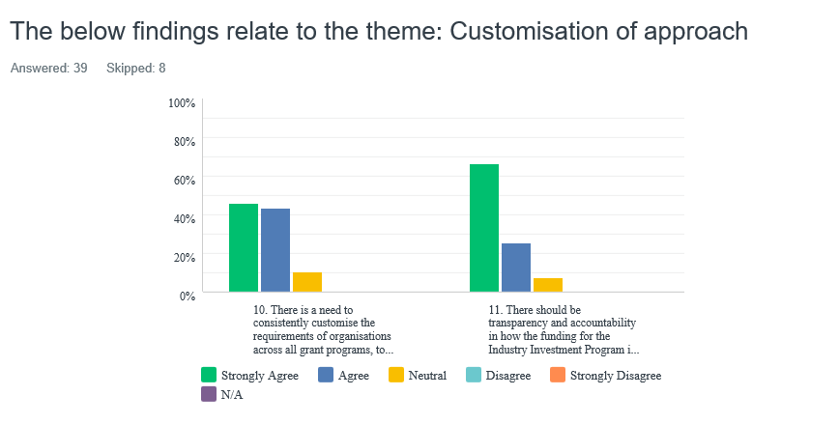
- In relation to point 11, within reason, there are commercial in confidence elements that must be considered, together with the fact that some sports are “in competition” for first choice athletes.
- 10, customisation should result in simplification.
- More frequent, smaller rounds of funding with some specific goals to be reflected will attract more commitment from the industry and is more achievable for organisations that have a seasonal participation compared to those activities that are based year-round, e.g. soccer, AFL versus mountain biking or archery.

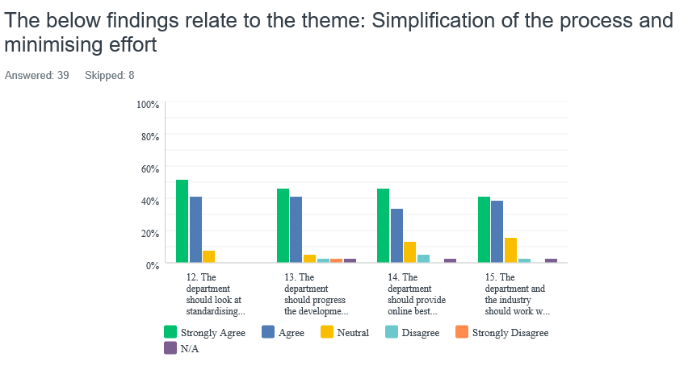
- In relation to point 15, very concerned by the push toward the unitary model by Sport Australia. Our SSA will not entertain this, so would ask DLGSC to respect the views of various SSAs in relation to this matter.
- SSAs need to understand the LGA context when undertaking their strategic plans, visions, etc.
- The department should maintain its focus on State issues, the respective NSOs can look after national issues affecting SSAs.
- So long as each of the State Sporting Associations has an understanding of their commitment to ensuring support to their members. The department could then be ensuring the State bodies are compliant.
- In relation to Finding 14, it may not necessarily be the department that provides this, it could be WASF, however SOMEONE needs to take responsibility for it.
- Standardising to consolidate, streamline and increase the efficiency of application and acquittal processes. Further work required for point 14, given the varying capacity, capability and the environment within which organisations operate.
- XXXXX have some concerns with the push from the Sports Commission toward a one management model. The concerns include but are not limited to: 1. How this could impact State funding going forward? 2. The capacity and capability of the national model to service WA. 3. The remote model allowing gaps to appear in current regional programs.
- Particularly with regard to the increasing levels of compliance that are impacting the volunteer obligations and willingness to support and participate in governance roles at club organisational level.

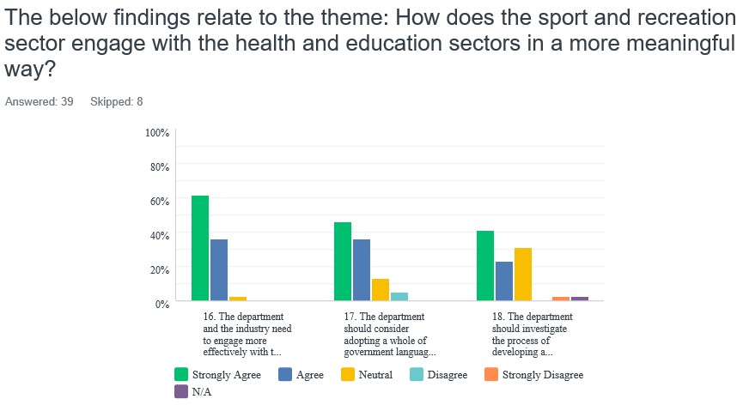

- Very confused about the role of Healthway in the new paradigm.
- The department needs to also include current relationships between SSAs, VenuesWest and WAIS which are government entities, which draw from the same pool of funds or are a significant venue provider.
- Q18 — an impossibility that would simply promote unsubstantiated guesswork by the SSA, with little or no factual supporting evidence. Pure recreation should not be included in any formal SSA calculations regarding sport.
- This has been a long time coming and recognition from the health and education sector of the importance of the physical and mental well-being provided by the sport and recreation industry should be promoted. Therefore, it would make sense to use the same terminology and measures for reporting.
- Health and education are significant sector, however local government, tourism, transport and treasury among others have impacts. It is more appropriate for government to adopt "common community language" that allows greater engagement and clarity.
- The current lack of "value" placed on the positive value of sports-related activities is disturbing.

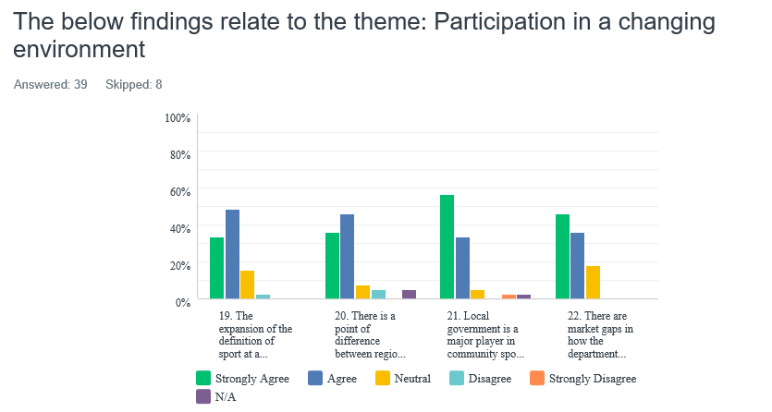

- The developing trend is competition from government in sport delivery. If DLGSC are acknowledging that they must enable SSAs to deliver sport and associated programs, the last thing we want is the baton to be simply handed to another government entity to do more of the same. LGAs are in the business of managing facilities, not delivering sport nor programs. The latest round of TPP funding saw sport competing “head to head” with LGAs for funding and with the enormous resources that an LGA has at its disposal, the result is bad for sport in this State.
- LGAs need significant work in relationships with sport and rec and not running programs which compete with what SSAs can provide.
- Regional clubs struggle to have the capacity to undertake SSA-driven initiatives, simply because of lack of resources. It appears in the last five years that the focus of LGAs has shifted from a community benefit driven entity to a financially beneficial driven entity which is extremely dangerous for sport and recreation.
- 21. Local government should still be scrutinised as a State body would be to ensure compliance and fairness. 22. Certainly, shorter turnaround time for small projects and support would assist with events and improve participation in the small windows of opportunity between major events.
- Understanding the relationship between physical activity (health terminology) and sport, particularly at a community level is constructive. The relationship between elite, high-performance sport (entertainment live and broadcast audiences) and physical activity is more tenuous. Point 20, access to services and resources over the delivery model may be the challenge
- Local government provides the facilities and should focus on this area as many are struggling, rather than providing club development staff

Any ideas or findings that we might have missed
- Yes. 1) Competition against government entities. 2) Lack of appreciation for the importance of funding core business whilst at the same time, expecting more governance and compliance. The National Redress Scheme (for example) will have an enormous impact on sport administrators and result in less emphasis on program delivery and more focus on bureaucracy. 3) Lack of recognition of SSAs who have followed the cues from the government to become more self-sufficient financially.
- No, but there continues to be a lack of support for Over 55s, with the vast majority of programs targeted at junior groups
- Local councils need to be more proactive in supporting SSAs operating in their jurisdictions.
- Participants in sport travel through a revolving door. There is a constant and consistent need for new members. A strong focus and funding focus should be on encouraging participation through grassroots mechanisms
- Not so much a finding, but just a request to clearly articulate the state of play after the sale of the TAB. Will the sale impact the funding pool and if so to what degree? Is there a guarantee that this funding will be available in the future? This I think leads into the issue of future communication and sharing information across industry. While all peak bodies play a vital role in communicating to our sector, the strategic funding review as a process has highlighted the need to ensure that we continue to meet to discuss broader issues and how we can share resources, knowledge and ideas
- Gender equality on boards. The problem I see here is that many SSO boards are determined by member voting and volunteers putting their hand up. Whilst we currently enjoy over 50% female representation on the board, this could change annually at the AGM
- Facility, VenuesWest. Sports associations and clubs are charged rental and hire for sports events. This cost element does not assist amateur sports to be self-sufficient.
- WAIS and the amount of funding into such a small percentage of the sporting community. Diminishes what available to the broader base of participation sports. Rugby has Olympic athletes but has to fund all athletes. What criteria applied to WAIS? How does WAIS demonstrate performance and representation of the value of the funds it receives?

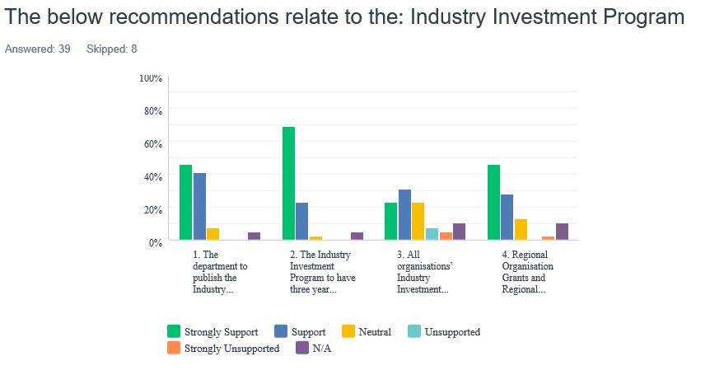

- Keep CSRFF funding separate.
- We are unsure what the “reset to the base funding level” means in practical terms. We would like to discuss this with you.
- Consolidating regional funding in whatever form needs to be dependent on the organisation having an implemented regional plan supported by evidence
- Once again, very concerned by DLGSC comments that some sports have been “over funded”. Speaking from an Olympic sport perspective, that is simply untrue and naive. If the comment refers to commercial sports, there is some validity in that, but once again, outside of the AFL, most sports are managed by professional, hardworking administrators who are working in the largest, most expensive State to do business in.
- Difficult to know until the dollars are shown for each category.
- Government guarantee of support to be confirmed before consolidation and resetting back to basics. Not sure what form this takes to ensure no disadvantage.
- Point 4 (incorporation of regional funding), only where this funding mount is above the IIP current threshold.
- Are peak bodies and IROs also included in the above? It only mentions SSAs. It is also recommended that definitions are provided on who is eligible for funding under this category particularly the Sports and Recreation Agents.
- We have concerns on point 3, whereby the level of funding for each category is not known and the way an organisation is allocated to a category could significantly affect their long-term viability.

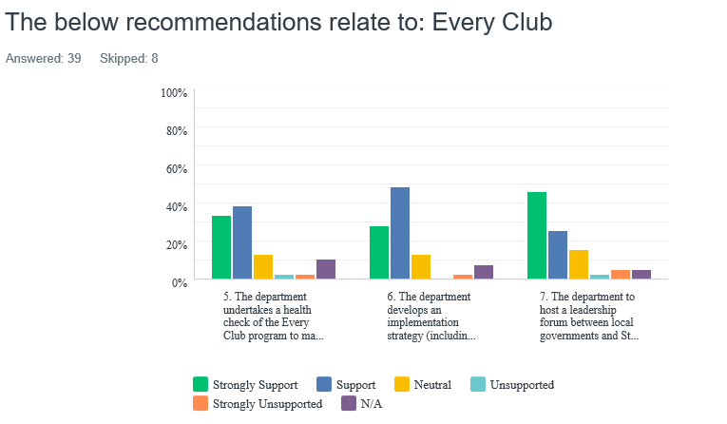

- Support a health check, do not support another full-blown review.
- See previous comments on direction of LGAs.
- 7. Most important. Some local governments are severely under-resourced in this area and there will need to be an agreement between those LGAs and the sporting bodies as to who is best placed to provide the service, particularly in some regional and rural areas. Some pressure may be required for LGAs to improve their sport and recreation delivery and resourcing, particularly if it can be aligned with the health sector.
- Funding to SSAs appears to support mid-tier competition rather than developing capacities and capabilities of grassroots/community sporting clubs. Registration fees for players, particularly juniors, appear to fund regional State league competition, e.g. import players, player fees etc, instead of investing in the growth of volunteers, coaches, players for local clubs. Recommended that there is clear agreement on where the funds are used and the measures, e.g. what percentage of funds are invested at club level, State, national competitions? LGAs’ support of sports that do not have an associated SSA should also be quantified, particularly with the growth of unstructured non-traditional sports.
- 5. There is a need for transparency in the health check of Every Club.
- Point 7 would make a big difference in terms of a greater understanding from SSA related to the limitations of local government, i.e. grass roots and community sport is by and large our focus and it is difficult at times to meet the constant demands from some sports to play all year round, e.g. soccer.

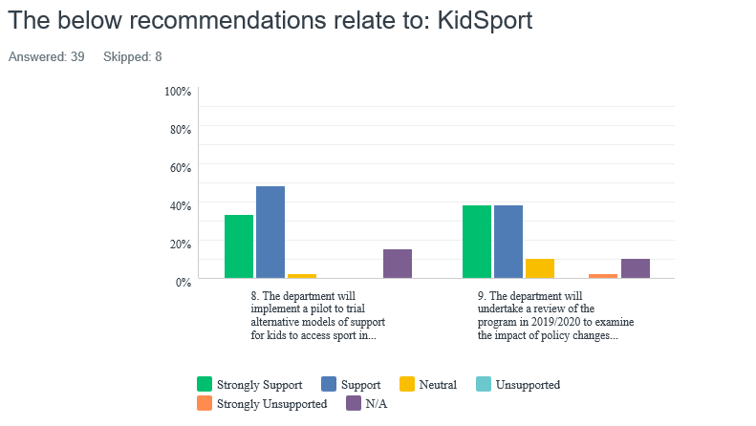
- 9. Need longer-term budget commitments to KidSport funding.
- Transparency of the review is highly recommended.
- The issue of funding for kids participating in organisations such as Scouts etc, these groups should be eligible as the skills learned with these groups are just as valuable if not more than participating in some sports.
- Develop more flexible payment model so that the voucher can integrate as a component of sport association registration systems more seamlessly.
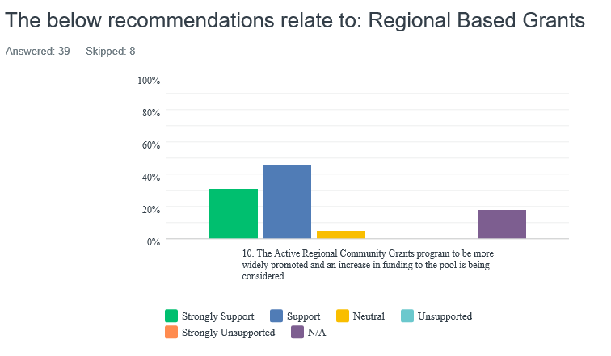

- Would prefer this to go to regional associations, not individual clubs unless there is a very strong, long-term plan. SSAs to be part of the selection process with consideration of how the application aligns with the SSA Strategic Plan mandatory.
- Wider promotion should be a positive. Clarity about the purpose and eligibility of the grants is a primary requirement.

Any other ideas?
- Timeline for the review of CSRFF.

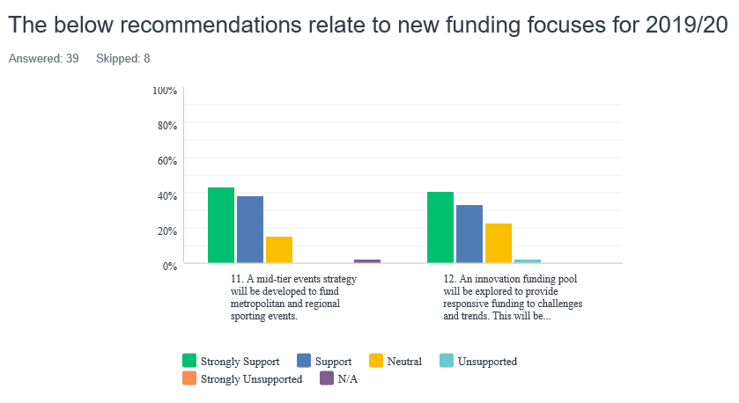

- Good ideas.
- Would like to see mid-tier events rolled into IIP but as long as there is a dedicated pool of funding for this, happy for it to remain separate. We have had huge success with this funding and it's the reason we attract events.
- The responsive funding is one particular area of improvement.
- Consideration for financial support for select, elite events to be staged in Perth/WA to help drive game promotion, awareness and profile to help game development and participation growth.
- Providing the "innovation pool" does not simply support the large associations.
- The review included few recommendations regarding recreation and unstructured activities, the review appeared "sports" focused. Consideration should be given to cultural variation in community needs and recreation and sport activities. Mobile clubs such as outdoor biking and walking groups are not tied to local government geographies or even land ownership, and have difficulty attracting facility funding. Recreation activity funding applications should be considered where there are multiple benefits.
- Both of the recommendations in 16 should be contingent on new funding sources.
- As previously stated, groups such as Scouts and Guides to be included.

IIP Specifically
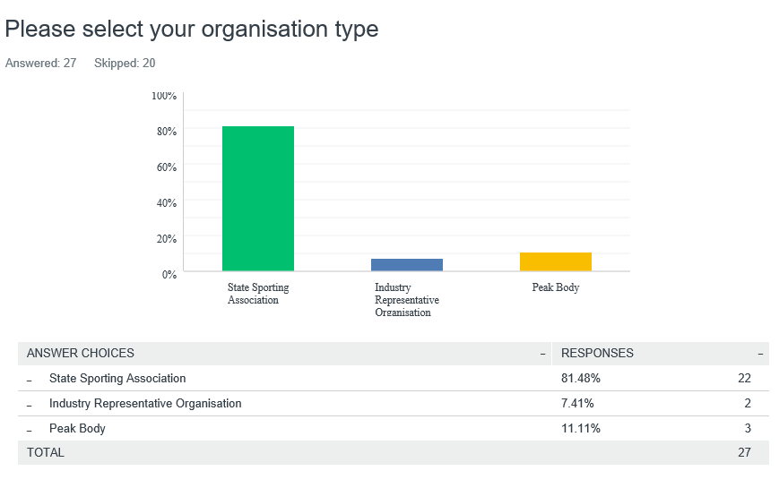
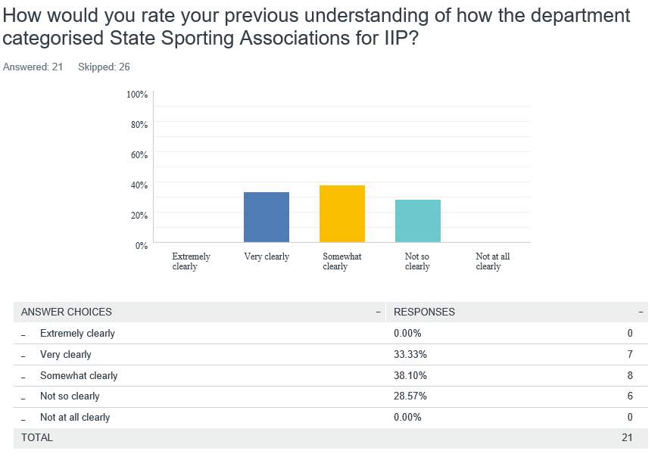

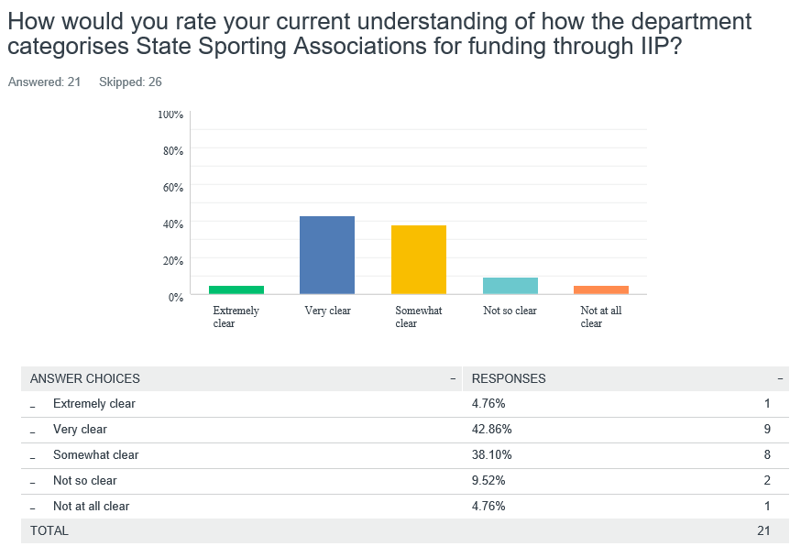

Feedback to the Categorisation Tables
Comments:
Workforce
- Not sure that sport can realistically expect to “buck the trends” of the wider business community here. Sport pays poorly and we expect a lot from our personnel. Tier C sports can't be expected to have full-time HR resources in place.
- The department will need to re-consider support in this area as it has been some years since direct assistance was provided. Most SSAs don't have an HR department!
- Voluntary only.
- No clear rating on part-time workforce. These are usually an important component of workforce with regard club level development and engagement activities
- I understand our staff don’t understand the mean score.
- Fair that it only applies to large organisations such as WACA. Have no comment on whether 75 is the right number.

Participation/Membership
- Tiers don't reflect WA sport. Too heavily weighted in lower tiers. For example, Category C — 20,000 members — is way too high.
- Very difficult to provide evidence-based statistics on participation, particularly in regional areas.
- This may change some levels if recorded differently from past years.
- Would agree with the ranges for each category.
- Don’t understand the mean score.
- Also comments about the numbers as statements but no context.
High Performance/Pathways
- Not sure the descriptors are correct. Where is the emphasis on DTE, athlete retention, etc. Appears to be a high emphasis on events. The fact is that most NSOs are based in the east and dislike staging major events in Perth due to cost to operate here and lack of alignment with mainstream media arrangements.
- High performance programs are in place and operational.
- International held events, national championships, junior and senior base, coach/official.
- HPP definition is clear in the detailed descriptors.
- We rate very high here but don't understand the mean score.
- No issues with categorisation.
Regional
- Simple solution: fund local SSA staff (can be shared) to deliver locally.
- Communication and quality of data provided remains a significant challenge in regional areas.
- The model of a week-long and event-based series of activations is a model used by a number of sports to provide value in regional areas. This seems to be supported as long as it is a "plan". Confirmation that the model of engagement with a week-long regional engagement is suitable would assist
- Feel as a % of total regions, probably 1-2 too high in the upper categories as some large sports have very few clubs in some regions.
Community Reach/Programming
- SSAs are very good at this and should be funded and supported for bridging the “divide” between sport and participation.
- Products in schools, organised sports, inclusive sports, club development plan, participation of events.
- Not clear what descriptors like "strong reach into community” means. Links to participation numbers? XXXXXX as a sport does all the activities listed but no qualification on the numbers to be defined at higher level of category.
- Strong community reach and inclusion program in particular remote Indigenous communities.
Governance
- An important, emerging requirement although care needs to be noted with a diminishing core of volunteers to carry out onerous governance requirements.
- Member protection, drugs in sport, sports betting, match-fixing, inclusion, 33% female board representation.
- General description and matrix approach are sound. Gender targets being arbitrary does not align with the actual principle of good governance if it is about "volunteer" boards with the correct skill matrix. This arbitrary direction is flawed in the principle of what governance is actually about, particularly on unpaid volunteer boards which is what applies at sporting organisation level.
- Some guidelines and direction need to be distributed to those organisations that are looking to increase their gender equity on boards.
Finance
- Similar to membership; the weighting is incorrect. Category C seeks 20,000 members and yet the SSA only needs to turn over $750K to $1M. Surely DLGSC wants to acknowledge and reward those SSAs that are attempting to secure their financial future and expand their sports, not penalise them.
- Matrix of financial value seems sound based on current understanding and feedback around the model.
- Based on accumulative value.
- Seems fair in terms of bands.

Planning
- Five-year strategic plan out to 2022, operational plan, annual budget, risk management framework, workforce development plan, marketing and comms plan, ICT strategy.
- Given the experience of DLGSC across multiple sporting associations, a template for a risk management matrix, asset management plan and workforce development plan, would be extremely valuable as these are tasks that are not always a primary skill set on boards or small operational management teams.
- Current strategic plan in place, budgets created annually.

Any additional comments regarding the IIP Categorisation
- Supported initiative.
- A crucial element of the table format is whether there will be or what level of scaling in each category associated with particular criteria will carry higher weighting in terms of moving up or down the financial metrics associated with the scale in each category band.
- I am confused how the mean score is worked out. That said, I have no idea as to which category our organisation would be considered to be in.
- The categories and their descriptors need a review and would not be something we'd support in their current form. Like the incremental tier concept to encourage SSAs to aspire to move up.
- Will wait and see how the numbers stack up against the responsibilities demanded.

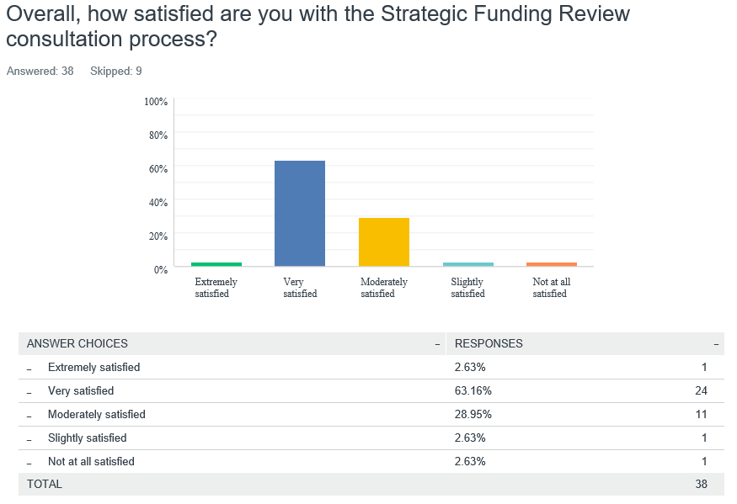

Final Comments
- Well done, DLGSC.
- The main item on the agenda for LGAs is that sport associations create their plans in isolation, thus not including LGAs. Most LGAs are cash, land and facility restricted yet every SSA wants to grow sport — which is good — but they do not take note of local context. For example, every SSA wants to increase participation in the north-east corridor so they establish clubs, etc. Yet there are no spare grounds, or even grounds to cater for more people. They should be encouraging/rewarding clubs that spread training days and times out (not just all between 5-7pm Tues and Thurs), be more flexible with match time, perhaps playing mid-week games, etc. If you only do what you have always done, they will only ever get what they already have. The female participation is very welcomed, but the SSA schedule every game at night. Most LGAs do not have 100 lux lighting, therefore can’t be done. $$ are required to provide infrastructure and the discussion around CSRFF and the like was not a part of this. LGAs must be involved in this discussion.
- I don't see how we can be reviewed appropriately when we have a different consultant each year. I also believe our reports are simply filed and not read,
- It has been disjointed through its delivery by PLA on behalf of the department.
- The opportunity to participate and have some genuine consultation and input is well received. This process of change management reflects a good model for engagement. The categorisation and change in funding associated with those sports that are self-sustaining is also well received by those sports in the lower categories.
- Superior to past consultation processes.
- My concern is that the lower profile sports are the ones that need the greatest level of support to be able to be competitive in the market. Our sport, XXXXXXXX, is an international sport and an Olympic sport but struggles for the media profile of larger sports in WA.
- XXXXXXX understand we fit into Category B, which fairly represents our activities. Our aim is to double our membership by 2025 and graduate to Category A.
- Focus should be on what changes will increase resources and capacity for community sport and recreation. An integrated approach facilitated by stronger relationships between the DGs of each of the key agencies across health, tourism, planning, transport and recreation is urgently required. Policy development at this level will help focus industry on priorities and multiple benefit outcomes, as opposed to singular benefit, popular, short-term projects. Financial efficiencies are also realised out of joint programs. This will enable multiple benefit funding programs and identify key issues that can be addressed through existing programs across different sectors. For example: events strategies and State tourism DBCA and LGA shared responsibilities. Access to common data.
Final questions:
1. How do you seek funding and support for activities that are not club-based?
2. How do LGAs support clubs that are not based in their region, e.g. mountain bike groups that are not based in Kalamunda?
3. Should funding be considered for incidental activity and life skills, e.g. learn to swim, Scouts, Girl Guides?
4. Impact of diversity of population and needs, how will we ensure our funding and support adapts?
5. Issues pertaining to funding, management and provision of infrastructure are more than just CSRFF review. It is recommended that the review is expanded. Serious consideration needs to be given to regional infrastructure and how this is planned for through the appropriate distribution of Royalties for Regions monies.
6. Clear outcomes for the Sports Wagering Account and Royalty for Regions will need to be articulated.
General feedback from workshops:
1. The language around “need” and “should” requires refining.
2. Improvements, by the simplification of application processes, would enable funding success for smaller organisations in particular.
3. Concern was raised for changing the initial question regarding funding programs being “effective” to “appropriate”. This was seen as a way forward for the department to meet different objectives to those intended with the initial question.
4. There was strong agreement on a need for customisation of the department’s approach, scaled for a wide range of community and sports groups, and commensurate with value and capacity.
5. Further consideration should be given to evaluating an applying organisation’s hours of (physical) activity, other than a sporting group’s membership.
6. The innovation funding pool imitative needs to clearly define “innovation” to avoid mis-directing funds to short-term outcomes. The use of criteria and clearly identified trends and broader issues will assist with targeting funds allocations appropriately.
7. A large part of the discussion was querying the CSRFF and State infrastructure which will be reported at a later date. Issues raised noted:
  - assistance for clubs with applications required
  - time frames for applications were too short, particularly given council reporting timeframes
  - local government budget timeframes and grants rounds are not aligned.
  - there is never enough funding for real impact on community infrastructure investment.
8. Participants are genuinely excited regarding the prospect of physical activity benefits from a revised focus of the department’s funding, which sits well with local government’s health plans and community programs.
9. An essential role of local governments is to connect community members, industry and department resources. This is not the role for SSAs. Therefore, the key need of local governments is to secure funding for better infrastructure and to implement community development plans.
10. It is unknown what the outcomes of a previous assessment of the CSRFF PRACSYS Report are, which would assist with benefits and short comings of the program.
11.There has been a concentration on competitive sports. The SSAs could take on more responsibility with community club development. It should be noted that some clubs are social unaffiliated social groups and have no access to funding.
12. The key to the success of funding community sports development is that by investing in the club, there is a positive multiplier effect on volunteers.
13. KidSport is underfunded.
14. Further investment in the pilot scheme SILVER, for older participants, should be considered.
15. Peak bodies require further funding as they disseminate information broadly across the sectors of industry and the region and will need to strengthen resources and capacities to respond to the repositioned core business of the department. Further defining the department’s and industry’s roles is required. It is agreed that the department should be facilitating and not directly delivering outcomes. It should help industry to grow and have an independent voice.
16. Communications and messaging from the department need to be clear and consistent (not only from the sport view).

